Harbor Seal Habitat Renovation
A Front-end Evaluation for the Seattle Aquarium
New Directions Project
Spring 2012

Research Team: Chris Cadenhead and Katie Phelps
Report reviewed by Nick Visscher and Angie Ong

Initial funding by

New Directions Partner Institutions
Executive Summary of Key Findings
This report presents the findings from a front-end evaluation prior to a renovation of the harbor seal habitat at the Seattle Aquarium. The study was undertaken to help Seattle Aquarium staff measure visitor knowledge of harbor seals, as well as illustrate visitor use of the current exhibit space. The intent was to inform the content of exhibit interpretive materials as well as provide a baseline for a summative study evaluating the success of changes made to the exhibit.

Methodology
Data was collected in February 2012 by a team of 10 first-year graduate student data collectors along with the two principle investigators. The evaluation was conducted using three instruments and resulted in the collection of 136 whiteboard knowledge activities, 104 reflective tracking interviews, and 128 timing and tracking instruments.

Principle Findings
Visitor Knowledge
- 62% of participants correctly identified a harbor seal. 22% chose the image of the fur seal, and 13% chose the sea lion.
- Visitors are more comfortable with facts that are observable in the local harbor seal population. These include: that harbor seals are common locally, that they haul out of the water, they have spots for camouflage, and that they are protected by law.
- Visitors are less familiar with information about harbor seal diet and eating habits.
- Visitors are most interested in knowing more about harbor seal behavior, the story of Barney and Q (the seals on display at the Aquarium), Seattle Aquarium animal training, and harbor seal habitats.
Current Exhibit Use
- There are five pathways used by visitors when exploring the harbor seal exhibit.
- 15.6% of visitors walked past the exhibit without stopping to look at the seals. The median time for those who did not stop was 8 seconds. Visitors who spent the most amount of time in the exhibit entered from the Family Orca Center, and stopped at both the inside and outside viewing areas. Visitors who took this route had a median time of 2 minutes and 12 seconds.
- Exhibit signage was only read by 12% of observed visitors. Of the four signs included in the exhibit, the most-looked at sign was the one that included information about and introductions to Barney and Q.
- Visitors recalled taking pathways and making stops in similar numbers to those observed during timing and tracking. Many did not explore the exterior portion of the harbor seal area because either it was cold and rainy, or they explained that were not aware that there was an outside viewing opportunity.
- About 75% of participants reported not reading signage, and many were not aware that there were any signs in the harbor seal area. Some did report taking photos and stopping to watch a feeding.
- Top participant recommendations for the space were geared toward increased visibility (lower viewing window for children/wheelchairs, underwater views), visitor comfort (more benches, more shelter) and seal well-being (larger habitat, more naturalistic habitat).
Implications for Seattle Aquarium
Comments provided by visitors, along with observations of their current use of the space support the need for a renovation of the harbor seal habitat. Data collected also suggests that current plans for the renovations align with visitor comments and support the opportunities explained further in the body of this document.
Introduction
Initially funded by the Institute for Museum and Library Services, "New Directions in Audience Research is a special initiative of the University of Washington Museology Graduate Program partnering with the Woodland Park Zoo. New Directions is designed to train Museology graduate students to understand, support, and engage in audience research and evaluation within informal learning settings. A key component of the training is partnering with local museums who serve as learning laboratories where students work to conduct on-site audience research, under the guidance of evaluation mentors and support staff.
Project Site
The Seattle Aquarium is located on the waterfront of downtown Seattle, Washington. It opened in 1977 and hosts approximately 800,000 visitors annually. The mission of the Seattle Aquarium is “Inspiring Conservation of Our Marine Environment.” The facility includes ten primary exhibit areas, which feature a variety of local and non-local marine animals.
Area of Interest
The Seattle Aquarium is about to undertake a 2.5 million dollar renovation of the harbor seal exhibit, scheduled to be complete in the summer of 2013. This project includes a total remodel of the seal habitat and accompanying interpretive materials. The harbor seal enclosure is one of the last original facilities at the Aquarium. It was originally part of a working fish ladder and thus is not ideal for visitor interaction with harbor seals.
Audience

This study will focus on visitors who experience the harbor seal habitat, ramp and finger pier. The Aquarium primarily caters to family and school groups so we anticipate a wide variety of participants.

Goals
This evaluation will be used to inform the interpretive messaging for the upcoming harbor seal exhibit area renovation. It will also provide a baseline for future evaluation of the exhibit space.
There are two primary objectives:
- Assess visitor knowledge and interest regarding harbor seals
- Evaluate visitor use of and attitudes toward current exhibit

Evaluation Questions
Visitor knowledge of harbor seals:
- What do visitors know about harbor seals?
- What are their misconceptions about the animals?
- What do they want to know about harbor seals?
Attitude toward and use of the current exhibit:
- What do people do in the current space?
- How much time to they spend there?
- What do visitors remember about their visit to the space?

Literature Review
To inform the methodology of this project we explored several similar front-end studies undertaken at aquariums and science centers. First, however, our rational for conducting a front-end study came from a reading of Steve Bitgood’s The ABCs of Label Design. In that article, he summarizes the good label design principles of several previously written papers. Five of the six recommendations he offers at the conclusion are evaluation related with the first clearly stating: “Use front-end evaluation to find out what the audience already knows, what they don’t know, where their interests lie, and to identify possible misconceptions,” and later on, “Use summative evaluation to see if the final product worked. Once final labels are installed, a final test can be conducted to ensure they are accomplishing their objectives,” (Bitgood, 1991). By focusing this research on informing more passive modes of interpretation (rather than the biologist or interpreter facilitated experiences) we were able to investigate more deeply what visitors might potentially take away from a visit through the harbor seal habitat.
We were encouraged to include highly visual and interactive elements after reading an article published in Learning Environments Research. Pictures are necessary but not sufficient: using a range of visual methods to engage users about school design took a mixed-methods approach to learn what all users; from students, to staff, to teachers thought about their current school/work environment. In addition to a photo elicitation exercise, the researchers included a mapping exercise where each participant drew out the paths that they generally took throughout a typical school day, added color-coding for places they liked and didn’t like, and also added comments and suggestions. This instrument was successful because it “provided a good starting point for conversation, perhaps better for some participants than photo elicitation.” By combining the maps (overlaying all the pathways as well as “hot” and “cold” spots on top of each other and analyzing the resulting compilation in conjunction with the individual comments made The researchers gained valuable insight into the overall use of the school.
Monterey Bay Aquarium Sharks and Rays Exhibition Front-End Evaluation was completed in 2002 by Randi Korn and Associates, Inc. in conjunction with the Monterey Bay Aquarium (Korn & Associates, 2002). The purpose of the evaluation was to gauge visitor perceptions and attitudes towards sharks and rays, while also evaluating engagement with initial exhibit concepts. The study concluded that visitors had a stronger associations and perceptions of sharks, and that few were passionate or knowledgeable about rays. Data was collected through a series of group interviews facilitated by a card sort activity. In this activity, visitors were given a set of cards, and instructed to make two piles, a pile for statements they agreed with, and a pile for statements they disagreed with. The use of a card sort activity was successful as it provided a language for visitors with varying degrees of knowledge on sharks and rays, which produced an informative conversation with evaluators. This methodology for knowledge assessment was adopted for this evaluation; a card sort activity was implemented as a way to measure visitor knowledge of harbor seals.
Similar methodology was used by Serrell & Associates in a front-end evaluation for the exhibit Infection Connection at the Liberty Science Center. Goals for the evaluation included gathering demographic information, and assessing visitors pre-existing knowledge and misconceptions of infectious diseases. The evaluation included a card sort activity similar to the activity used by Randi Korn and Associates, Inc. at the Monterey Bay Aquarium. In order to assess pre-existing knowledge of infectious disease, visitors were asked to sort cards listing “common diseases throughout the world,” (Serrell, 2002) into two piles: infectious and noninfectious disease. From this activity, evaluators discovered that most surveyed visitors could correctly identify infectious and noninfectious diseases, and therefore were familiar with the differences. This activity supplemented an informational interview, and helped visitors feel comfortable with the specialized vocabulary related to the topic. The success of this activity influenced the True/False card sort implemented in the Harbor Seal Front End Evaluation.
An additional front-end evaluation by Beverly Serrell and Associates informed our methodology and instrument development. Her team worked with the Florida Aquarium to inform the exhibit team of visitor’s entry-level understanding of invasive species {CITATION}. A Front-end Evaluation on Invasive Species for the Florida Aquarium also utilized a card sort activity in addition to collecting brief demographics. Visitors were asked if this was their first visit to the aquarium as well as if they possessed any prior knowledge or special interest in invasive species. They then were asked if they had heard of native and invasive species and provide examples of each. For the card sort portion of this study all the photo cards provided were of invasive species and data collectors reported that visitors were very interested in learning the correct answers and were surprised to hear them. We kept in mind the natural curiosity that participants would probably express and designed the order of questions and activities in our study accordingly.
Methods
Instruments
We utilized a mixed-methods approach to assess visitor knowledge and interest in harbor seals as well as their use of the current habitat area. Our research goals necessitated the use of three different data collection methods, collected independently of each other.
To assess general understanding, misconceptions, and audience interest in harbor seals we designed a multi-part instrument utilizing a magnetic whiteboard. This included seal photo identification, a true/false card sort, and a brief survey.
Timing and tracking was used to determine where visitors went, what they attended to, and how long they spent in the area.
A data collector administered reflective tracking map was used to facilitate conversations where participants were asked to reflect upon what they did in the exhibit space and why. In an attempt to capture a variety of visitor experiences, data collectors did not use a specific set of interview questions, and instead let comments guide the content of the conversation.
Nomenclature
Exhibit: The term “exhibit” is used when referring the harbor seal space from the perspective of the visitors.
Habitat: The term “habitat” is used when referring to the harbor seal space from the perspective of the animals.
“Training and Tricks”: As a part of the survey created to gauge audience interests related to harbor seals, we include a category called “Training and Tricks.” This category was created in the interest of mediating Aquarium Staff vocabulary with a vernacular that visitors would be more familiar with. This category was clarified with a descriptive statement, “I’d like to know more about why captive seals are trained.”
Sample Size
Based on recommendations in Judy Diamond’s Practical Evaluation Guide, we collected a total of 368 instruments (136 whiteboards, 104 reflective tracking, 128 timing and tracking) in order to have a sample representative of the Aquarium visitor population (about 800,000/year) with a margin of error of +/-10%.
Sampling Method
Data collection took place during the winter season, when the exhibit is exposed to wind and rain. In anticipation of impact on attendance rates, convenience sampling was used. Instruments were collected independently of each other and it is not required that a visitor complete all three. We implemented a cross-selection of casual visitors by approaching the first adult person to cross an imaginary boundary of our research area. Visitors who declined participation were counted as a non-response.
Statistical Analysis
Simple descriptive statistics were run using Microsoft Excel. As most responses were formatted to be nominal, the results are straightforward. Some open-ended thoughts visitors were taking away were compared with the various visitorship data we collected. Straight answers to questions and comparative results will be discussed in the next section.

RESULTS
Whiteboard Knowledge Activity
Demographics
Question 1: Have you been to the Seattle Aquarium before?
Two-thirds of respondents had previously visited the Seattle Aquarium.
Response | Number | Percentage
Yes | 65 | 65%
No | 35 | 35%
Total approached | 135
Declined/no answer | 35 | 26%

Question 2: Have you seen the harbor seal exhibit?
Approximately half of respondents had previously seen the harbor seal exhibit.
Response | Number | Percentage
Yes | 50 | 51%
No | 49 | 49%
Total approached | 135
Declined/no answer | 36 | 27%

Question 3: Have you seen a Marine Mammal presentation? If yes, which one?
Over three quarters of respondents had not seen a Marine Mammal presentation. Only eight of the 20 respondents who answered “yes” could name which talk they saw and no pattern emerged from their responses.
Response | Number | Percentage
Yes | 20 | 22%
No | 70 | 78%
Total approached | 135
Declined/no answer | 45 | 33%

Question 4: Do you have outside (prior) knowledge of seals? If yes, how so?
Over half of respondents (58%) said they had prior knowledge of harbor seals. The sources of their outside knowledge are presented in the chart below.
Response | Number | Percentage
Yes | 38 | 42%
No | 53 | 58%
Total approached | 135
Declined/no answer | 44 | 33%

Matching Photos
Image 1
104 responses

This was a “freebie” and most people got this correct.

Image 2
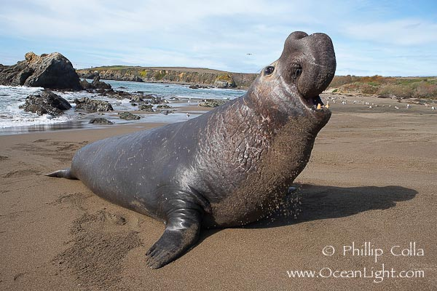
104 responses

This was not intentionally a “freebie” but most people identified this animal correctly.

Image 3
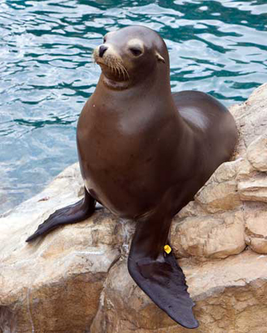
104 responses

Almost two-thirds (65%) of participants correctly identified the fur seal. It was most often confused with the harbor seal.

Image 4
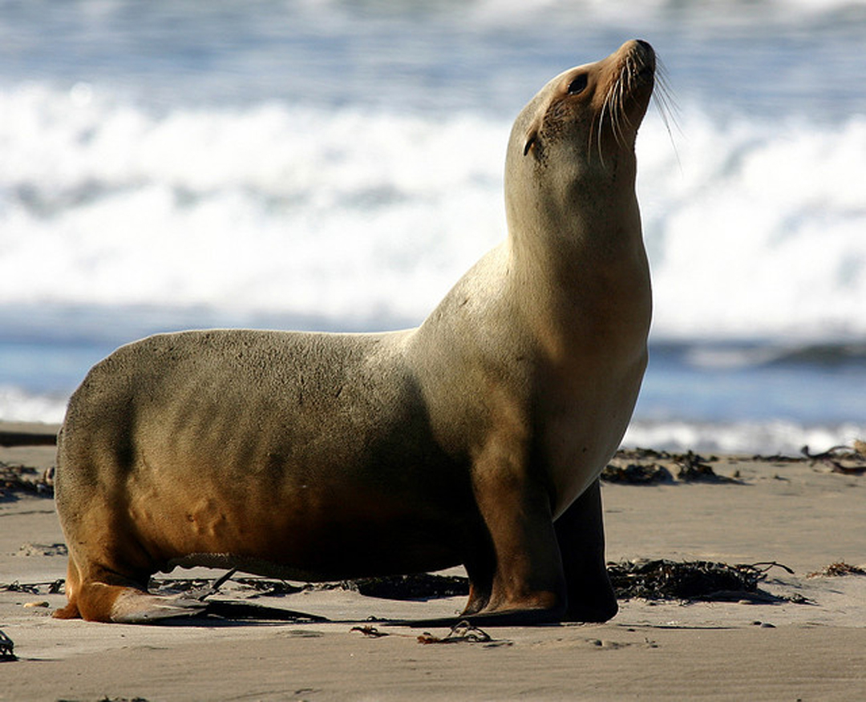
105 responses

71% of participants correctly identified the sea lion. This was the most well-known of the three challenging seal photos.
Image 5
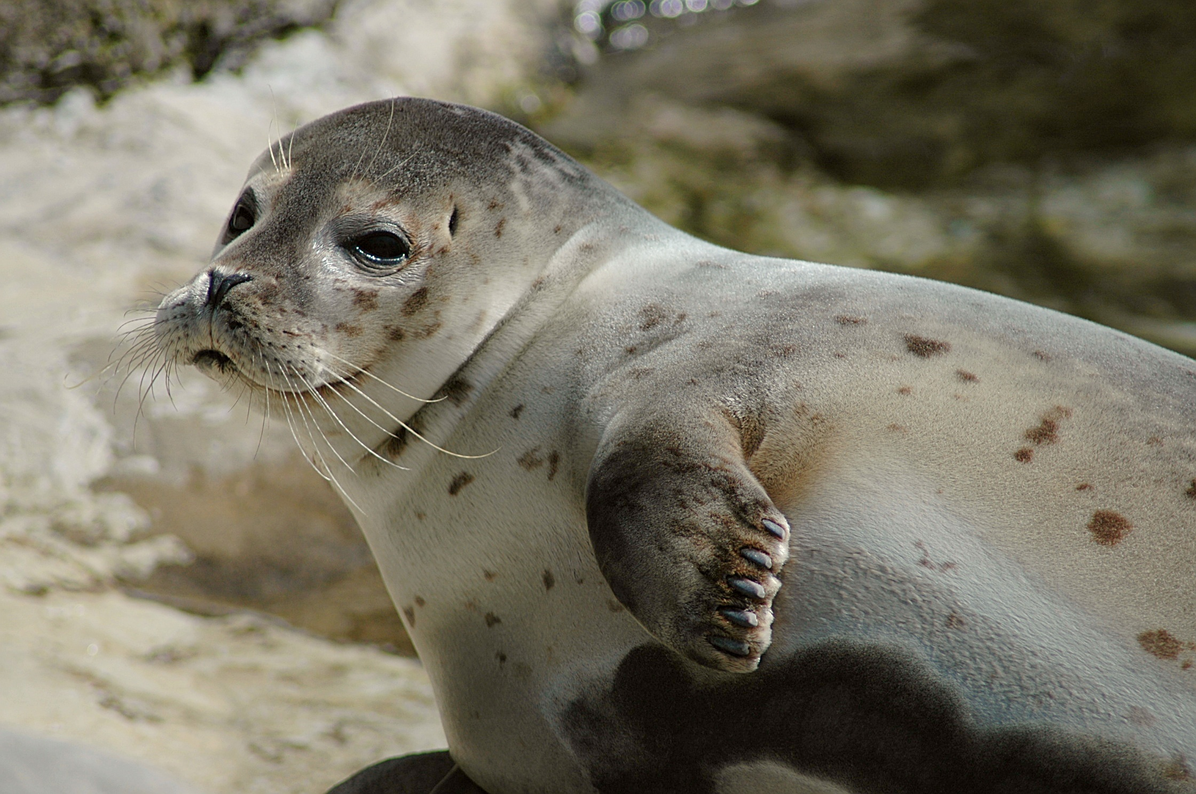
105 responses

62% of participants correctly identified the harbor seal. Almost a quarter (22%) chose the fur seal and about one in ten (13%) chose the sea lion.

Image 6
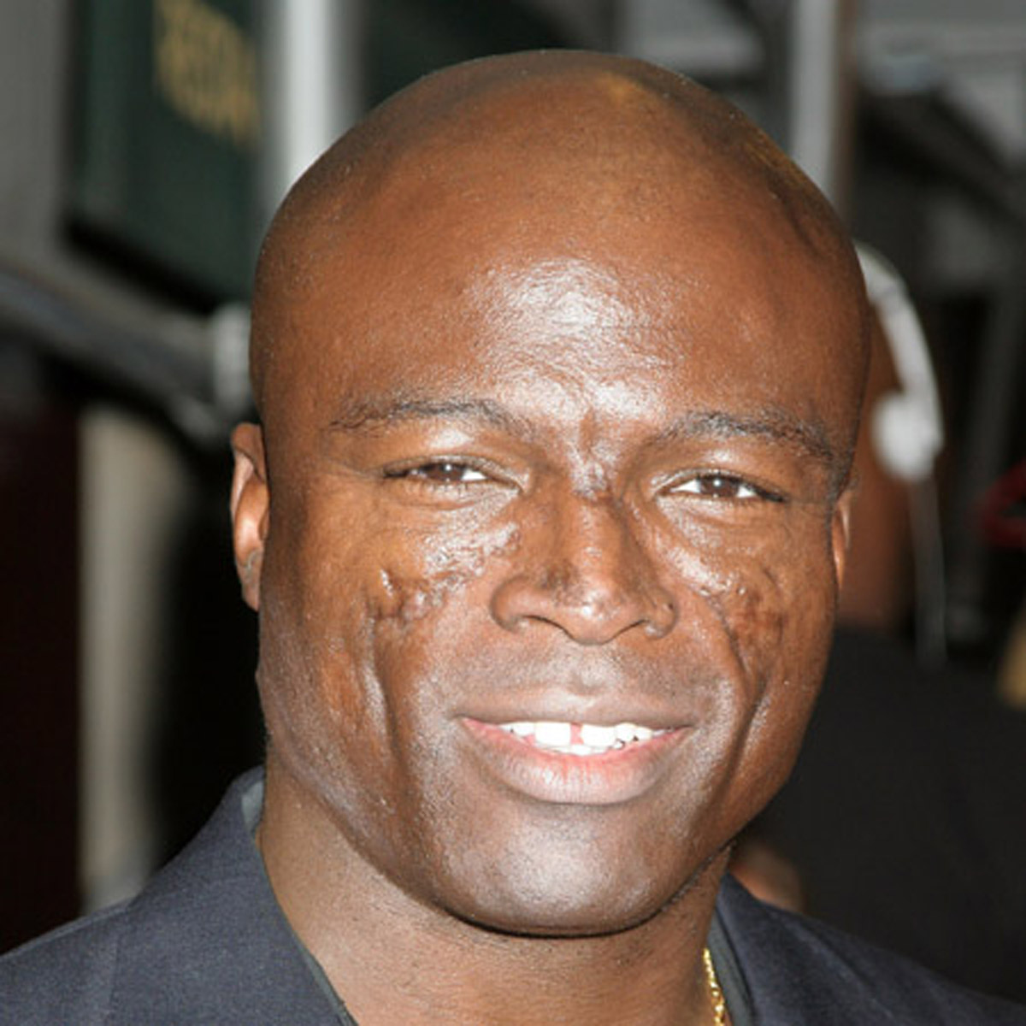
104 responses

This was a “freebie” and most people got this correct.

Why do you think this one is a harbor seal?

When correct, 39% of participants who gave a reason for choosing the harbor seal said they had seen one before. 30% cited process of elimination or guessing. Many (15%) also stated that they chose the one with spots, a response that did not come up when the participant guessed wrong.

Almost half (47%) of respondents who mis-identified the harbor seal (and gave a reason) said they guessed or used process of elimination. Almost a quarter (23%) said they had seen one before. The three “other” responses in this case referred specifically to aspects of the photograph that was presented (it [the animal] looked dry, they [harbor seals] like rocks, it’s on a beach).
Harbor Seal Facts – True/false activity
- Harbor seals “haul out” to bask in the sun and sleep. (TRUE) n=88, 12 declined
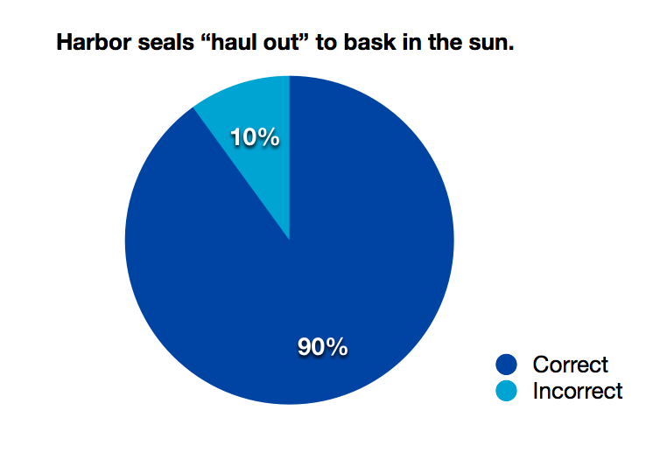

- Harbor seals are the most common local marine mammal. (TRUE)
n=88, 13 declined
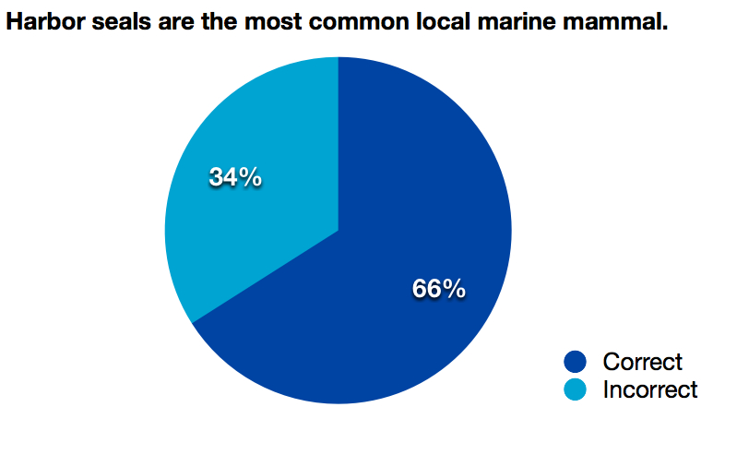

- Baby harbor seals are protected by law. (TRUE) n=88, 13 declined
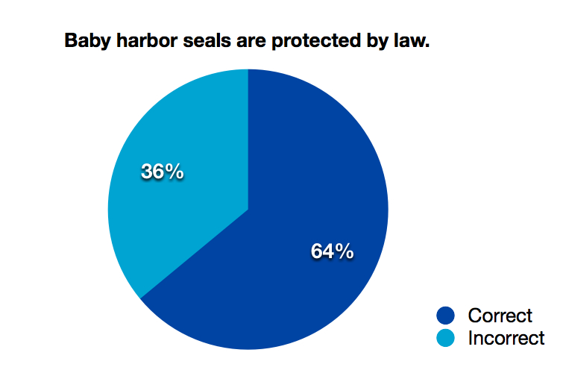

- The spots on their fur provide camouflage. (TRUE) n=88, 13 declined
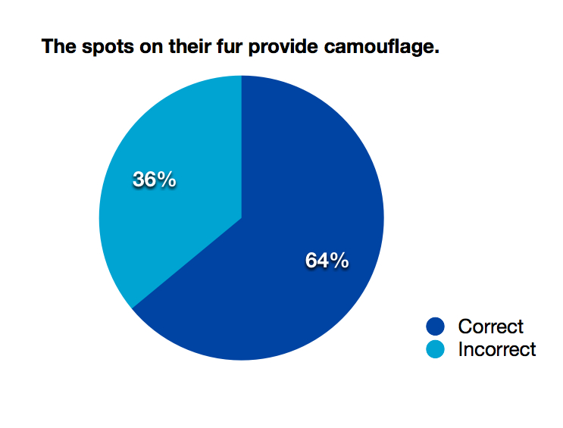

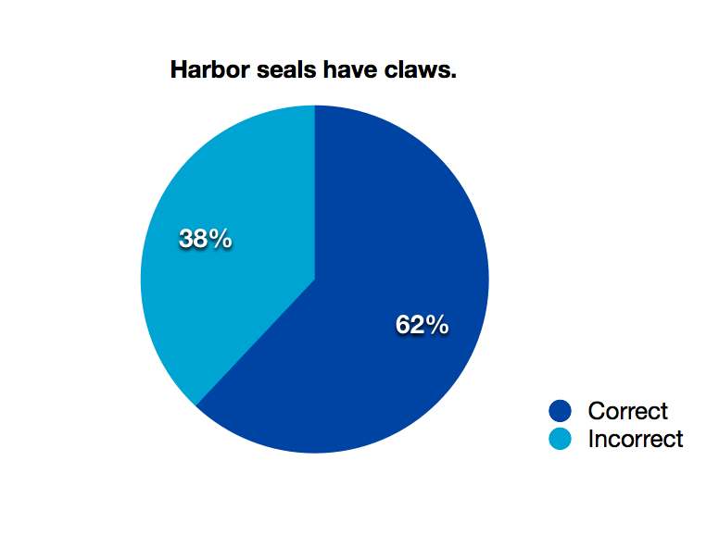
- Harbor seals have claws. (TRUE) n=85, 12 declined

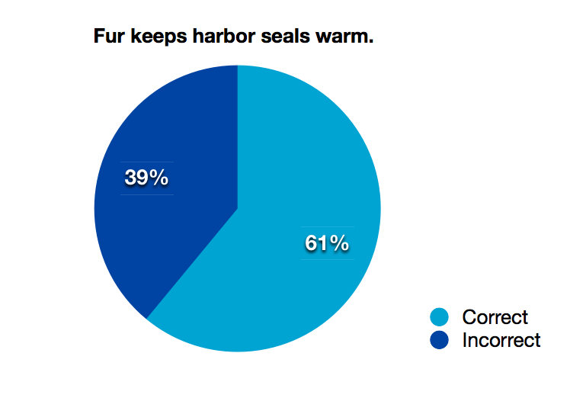
- Fur keeps harbor seals warm. (FALSE) n=88, 12 declined

- Harbor seals are omnivores. (FALSE) n=86, 12 declined
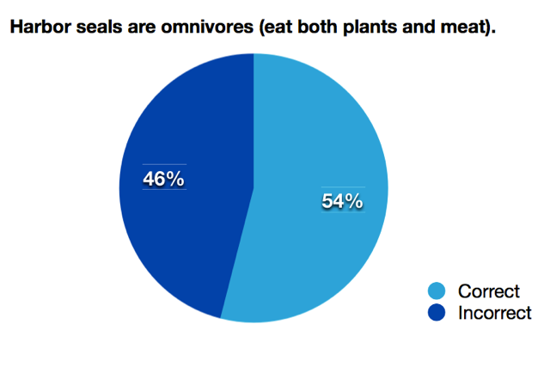

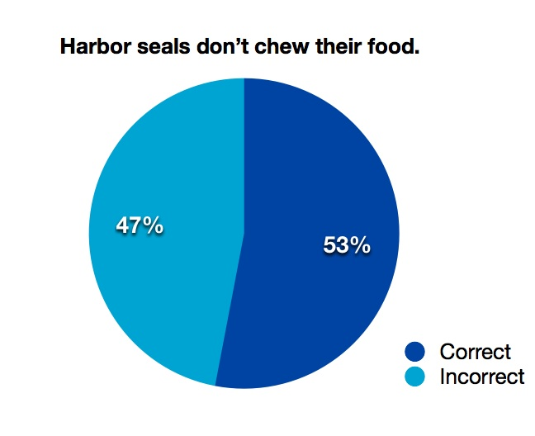
- Harbor seals don’t chew their food. (TRUE) n=88, 13 declined

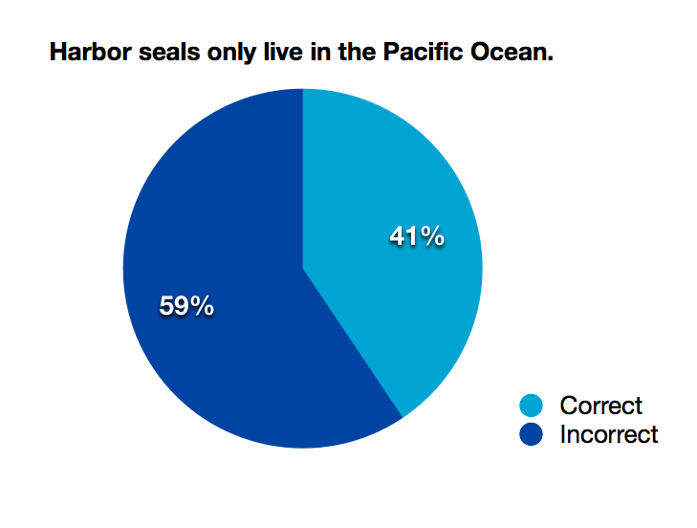
- Harbor seals only live in the Pacific Ocean. (FALSE) n=88, 15 declined

- Harbor seals have exterior ears. (FALSE) n=88, 11 declined
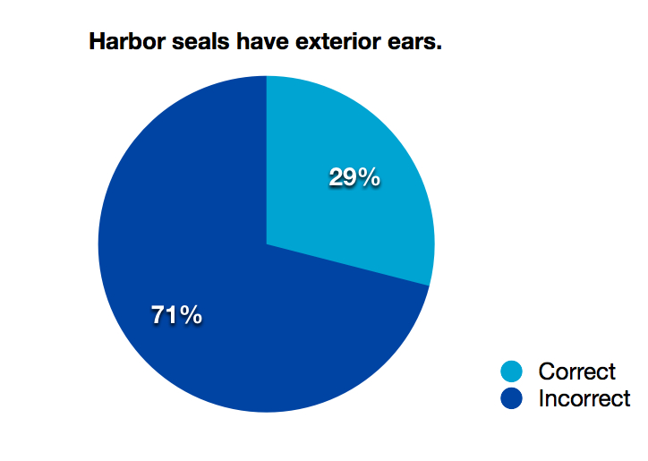

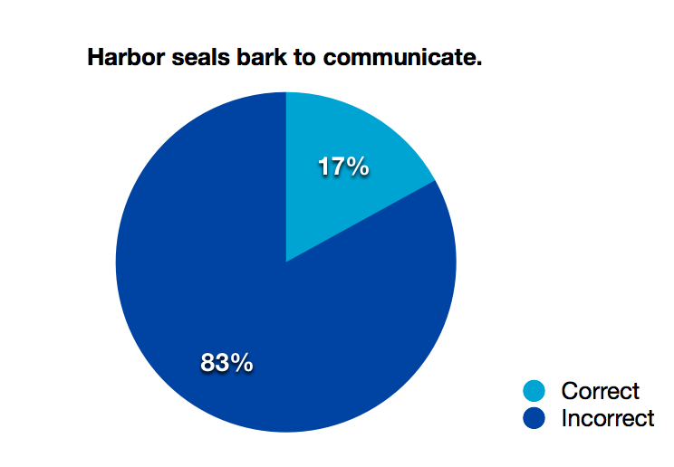
- Harbor seals bark to communicate. (FALSE) n=87, 11 declined

Visitor Interest:
Circle three things you would like to know about harbor seals.

Occasionally visitors chose more, or less, than three topics. This chart represents all of the instances of a topic being circled. We provided blank space for participants to include their own ideas and the only two write-ins “the N.A.V.Y. seals” and “pirahnnas” were meant to be humorous and therefore not included in the above chart.

Timing and Tracking
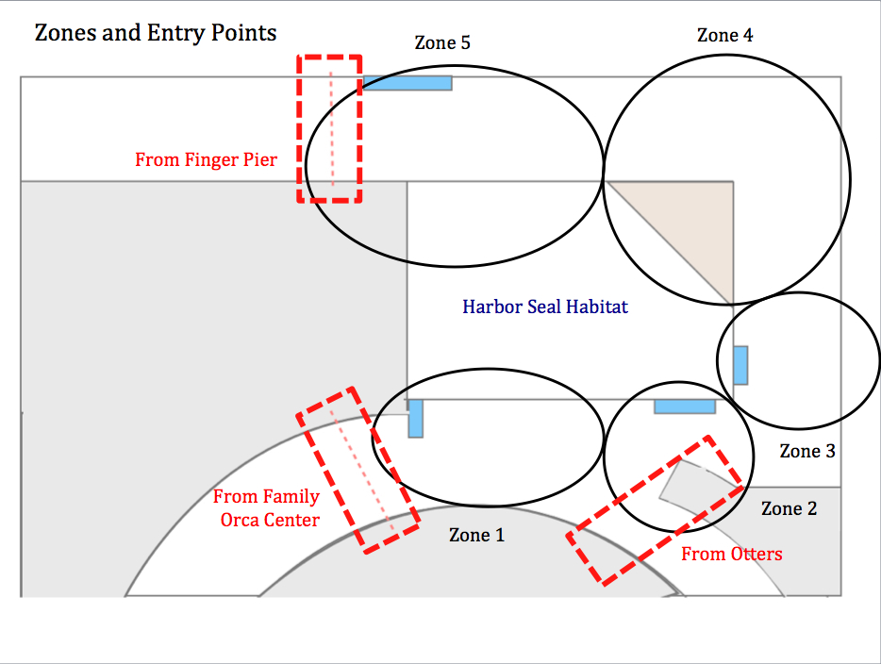
Visitors moved through the space in one of five pathways. If they stopped, their activities took place in one of five zones. Below is a map showing zones that were identified as well as entry points to the space. Also below is a chart summarizing the time spent and average stops for each of the five pathways.

 | Straight Through | Hallway Only | Hallway,  went outside | From  Finger Pier | From  Otters
Total instruments | 20 | 40 | 43 | 14 | 11
Average stops per instrument | 0 | 1.25 | 2.86 | 2.57 | 1.45
Minimum time spent | 3 seconds | 11 seconds | 17 seconds | 35 seconds | 6 seconds
Maximum time spent | 19 seconds | 3 minutes,  36 seconds | 7 minutes,  32 seconds | 12 minutes,  19 seconds | 4 minutes,  5 seconds
Average time spent | 9 seconds | 1 minute,  4 seconds | 2 minutes,  39 seconds | 3 minutes,  11 seconds | 1 minute,  27 seconds
Median time spent | 8 seconds | 50 seconds | 2 minutes,  12 seconds | 1 minute,  49 seconds | 1 minute,  14 seconds

Pathway – Straight Through
Visitors enter from the Family Orca Center and walk along the hallway without stopping to view the harbor seals.
Straight Through
Total instruments | 20
Average stops per instrument | 0
Minimum time spent | 3 seconds
Maximum time spent | 19 seconds
Average time spent | 9 seconds
Median time spent | 8 seconds

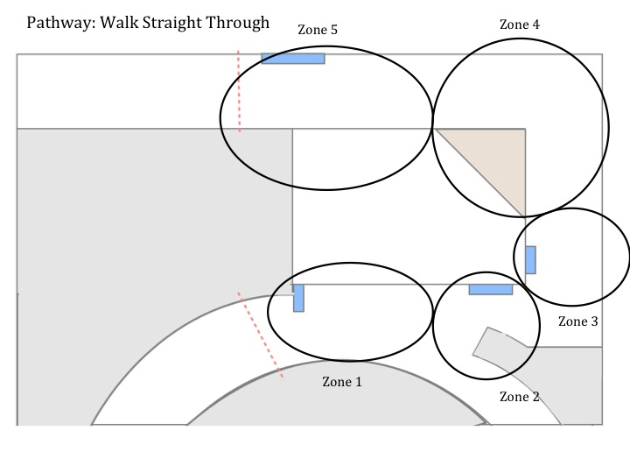
Pathway – Hallway Only
Visitors enter from the Family Orca Center and walk along the hallway, exiting towards the sea otters. In this pathway, visitors do not go outside onto the pier.
Hallway Only
Total instruments | 40
Average stops per instrument | 1.25
Minimum time spent | 11 seconds
Maximum time spent | 3 minutes, 36 seconds
Average time spent | 1 minute, 4 seconds
Median time spent | 50 seconds

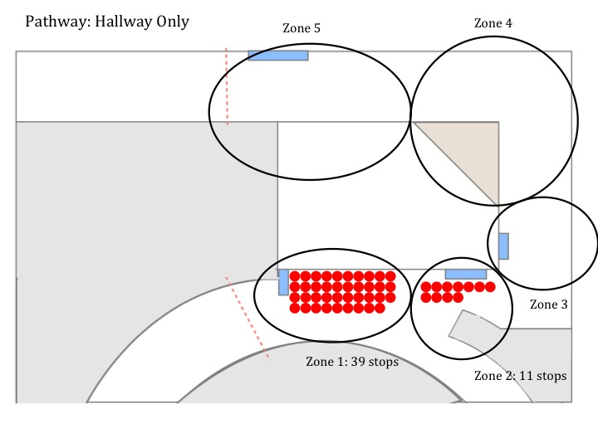

Pathway – Hallway, Went Outside
Visitors enter from the Family Orca Center, walk along the hallway and detour to the exterior of the harbor seal area before continuing on towards the sea otters.
Hallway, Went Outside
Total instruments | 43
Average stops per instrument | 2.86
Minimum time spent | 17 seconds
Maximum time spent | 7 minutes, 32 seconds
Average time spent | 2 minutes, 39 seconds
Median time spent | 2 minutes, 12 seconds

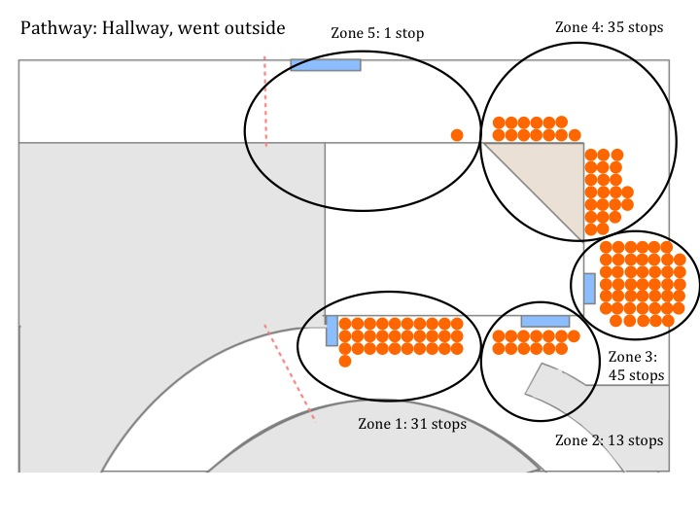

Pathway – From Finger Pier
Visitors start out at the exterior of the exhibit having walked north along the finger pier. They then exit by many pathways.
From Finger Pier
Total instruments | 14
Average stops per instrument | 2.57
Minimum time spent | 35 seconds
Maximum time spent | 12 minutes, 19 seconds
Average time spent | 3 minutes, 11 seconds
Median time spent | 1 minute, 49 seconds

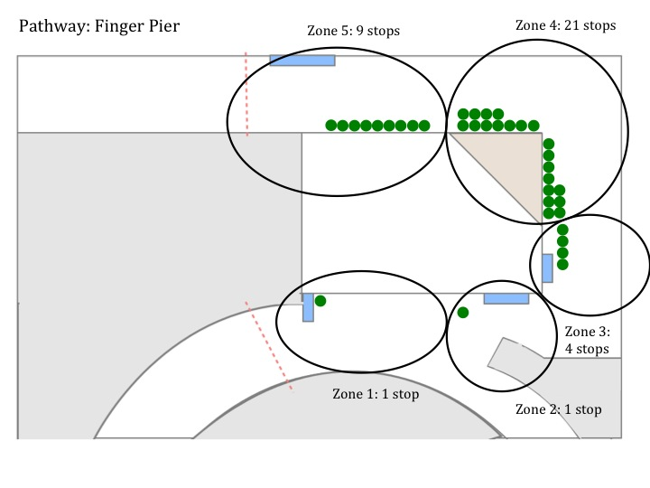

Path – From Otters
Visitors enter from the otter area, in the reverse direction of typical flow of traffic.
From Otters
Total instruments | 11
Average stops per instrument | 1.45
Minimum time spent | 6 seconds
Maximum time spent | 4 minutes, 5 seconds
Average time spent | 1 minute, 27 seconds
Median time spent | 1 minute, 14 seconds

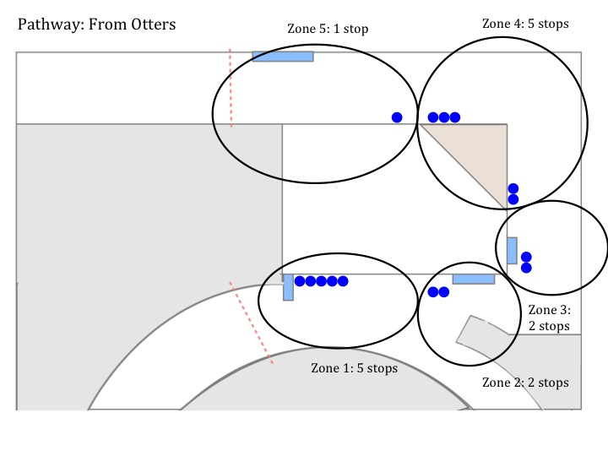

Instances of groups reading signage
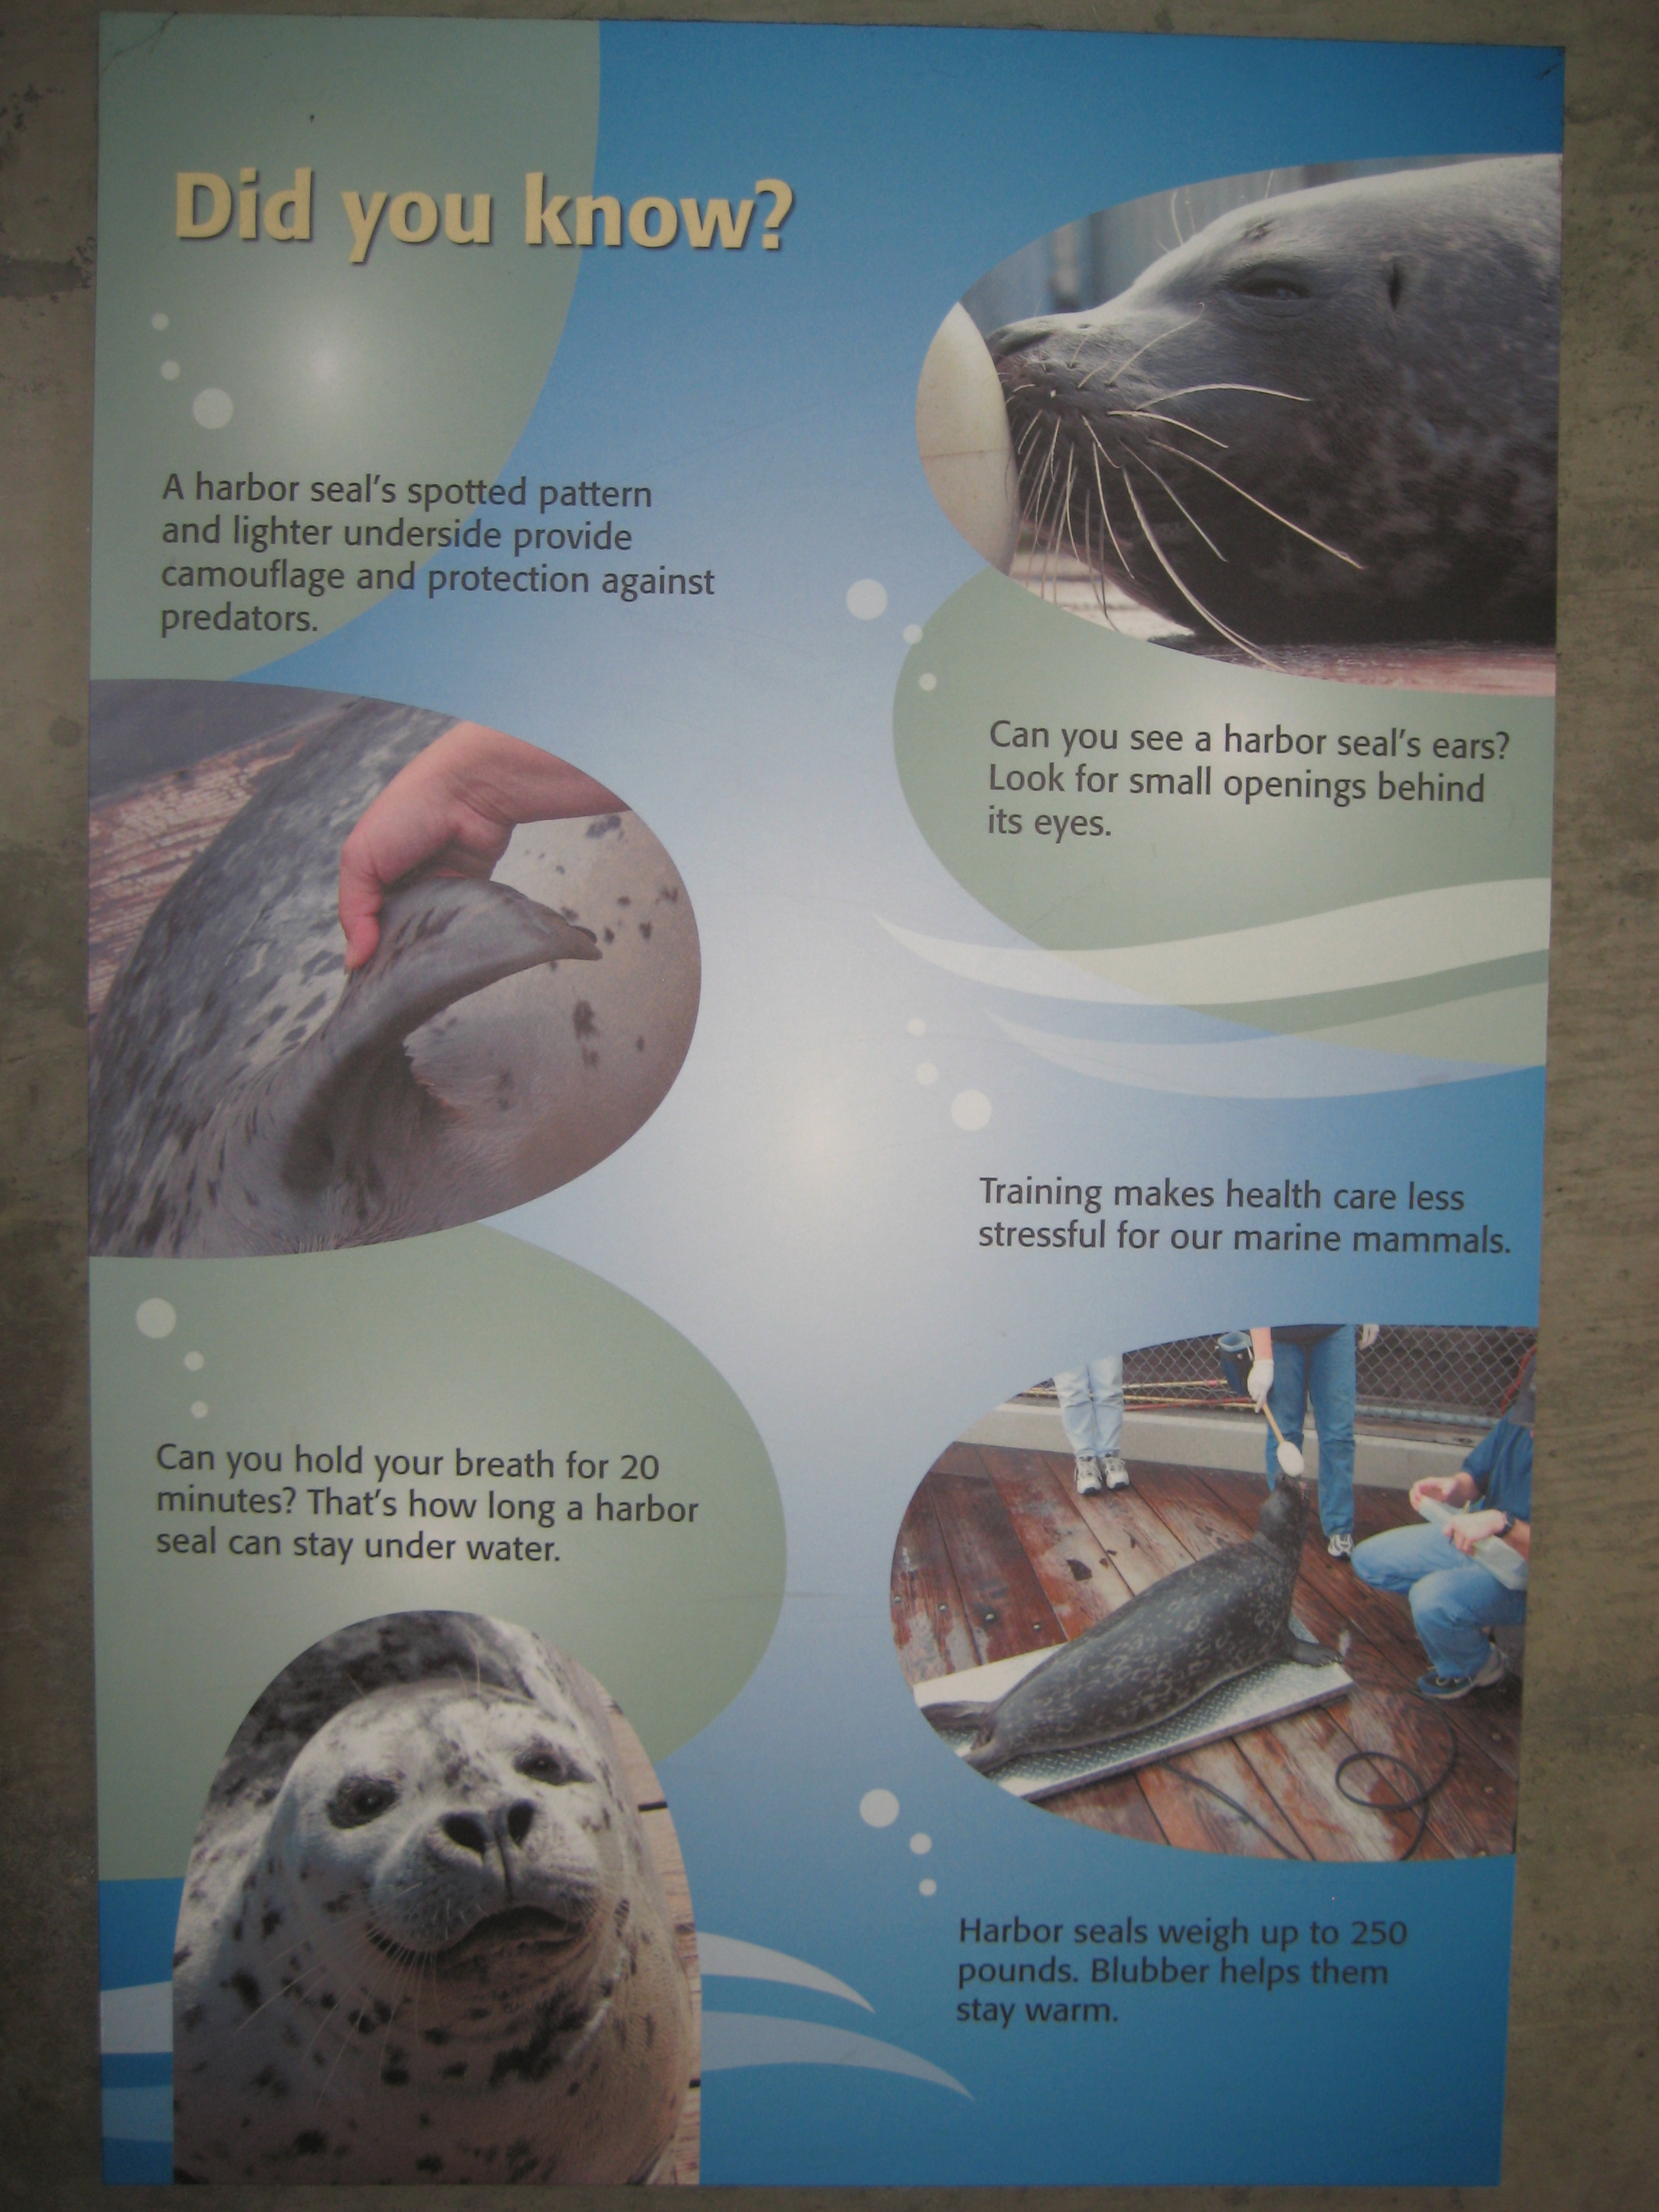
Of the 128 timing and tracking instruments collected, 15 where visitors (or 12% of the total observed population) were observed reading signs. The instances of each sign being attended to are described below. Only one individual/group read more than one sign.
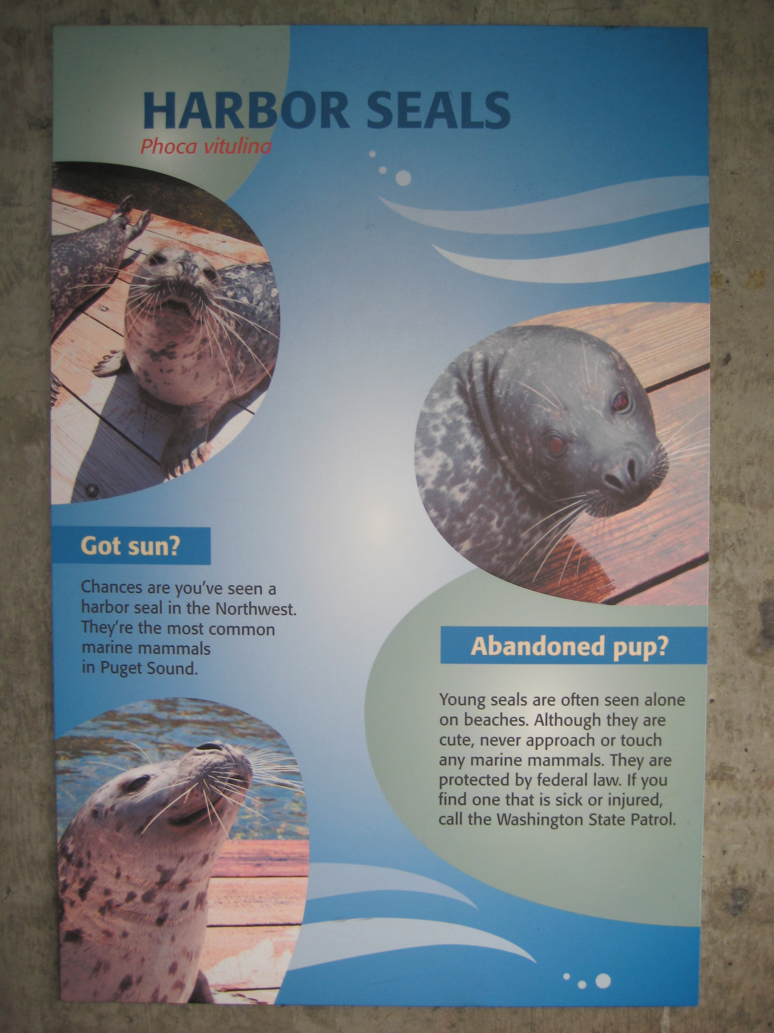

Four individuals/groups were observed reading the sign about Harbor Seals to the left of the observation window.
Two individuals/groups were observed reading the Did you know? sign just before the exit to the exterior of the harbor seal

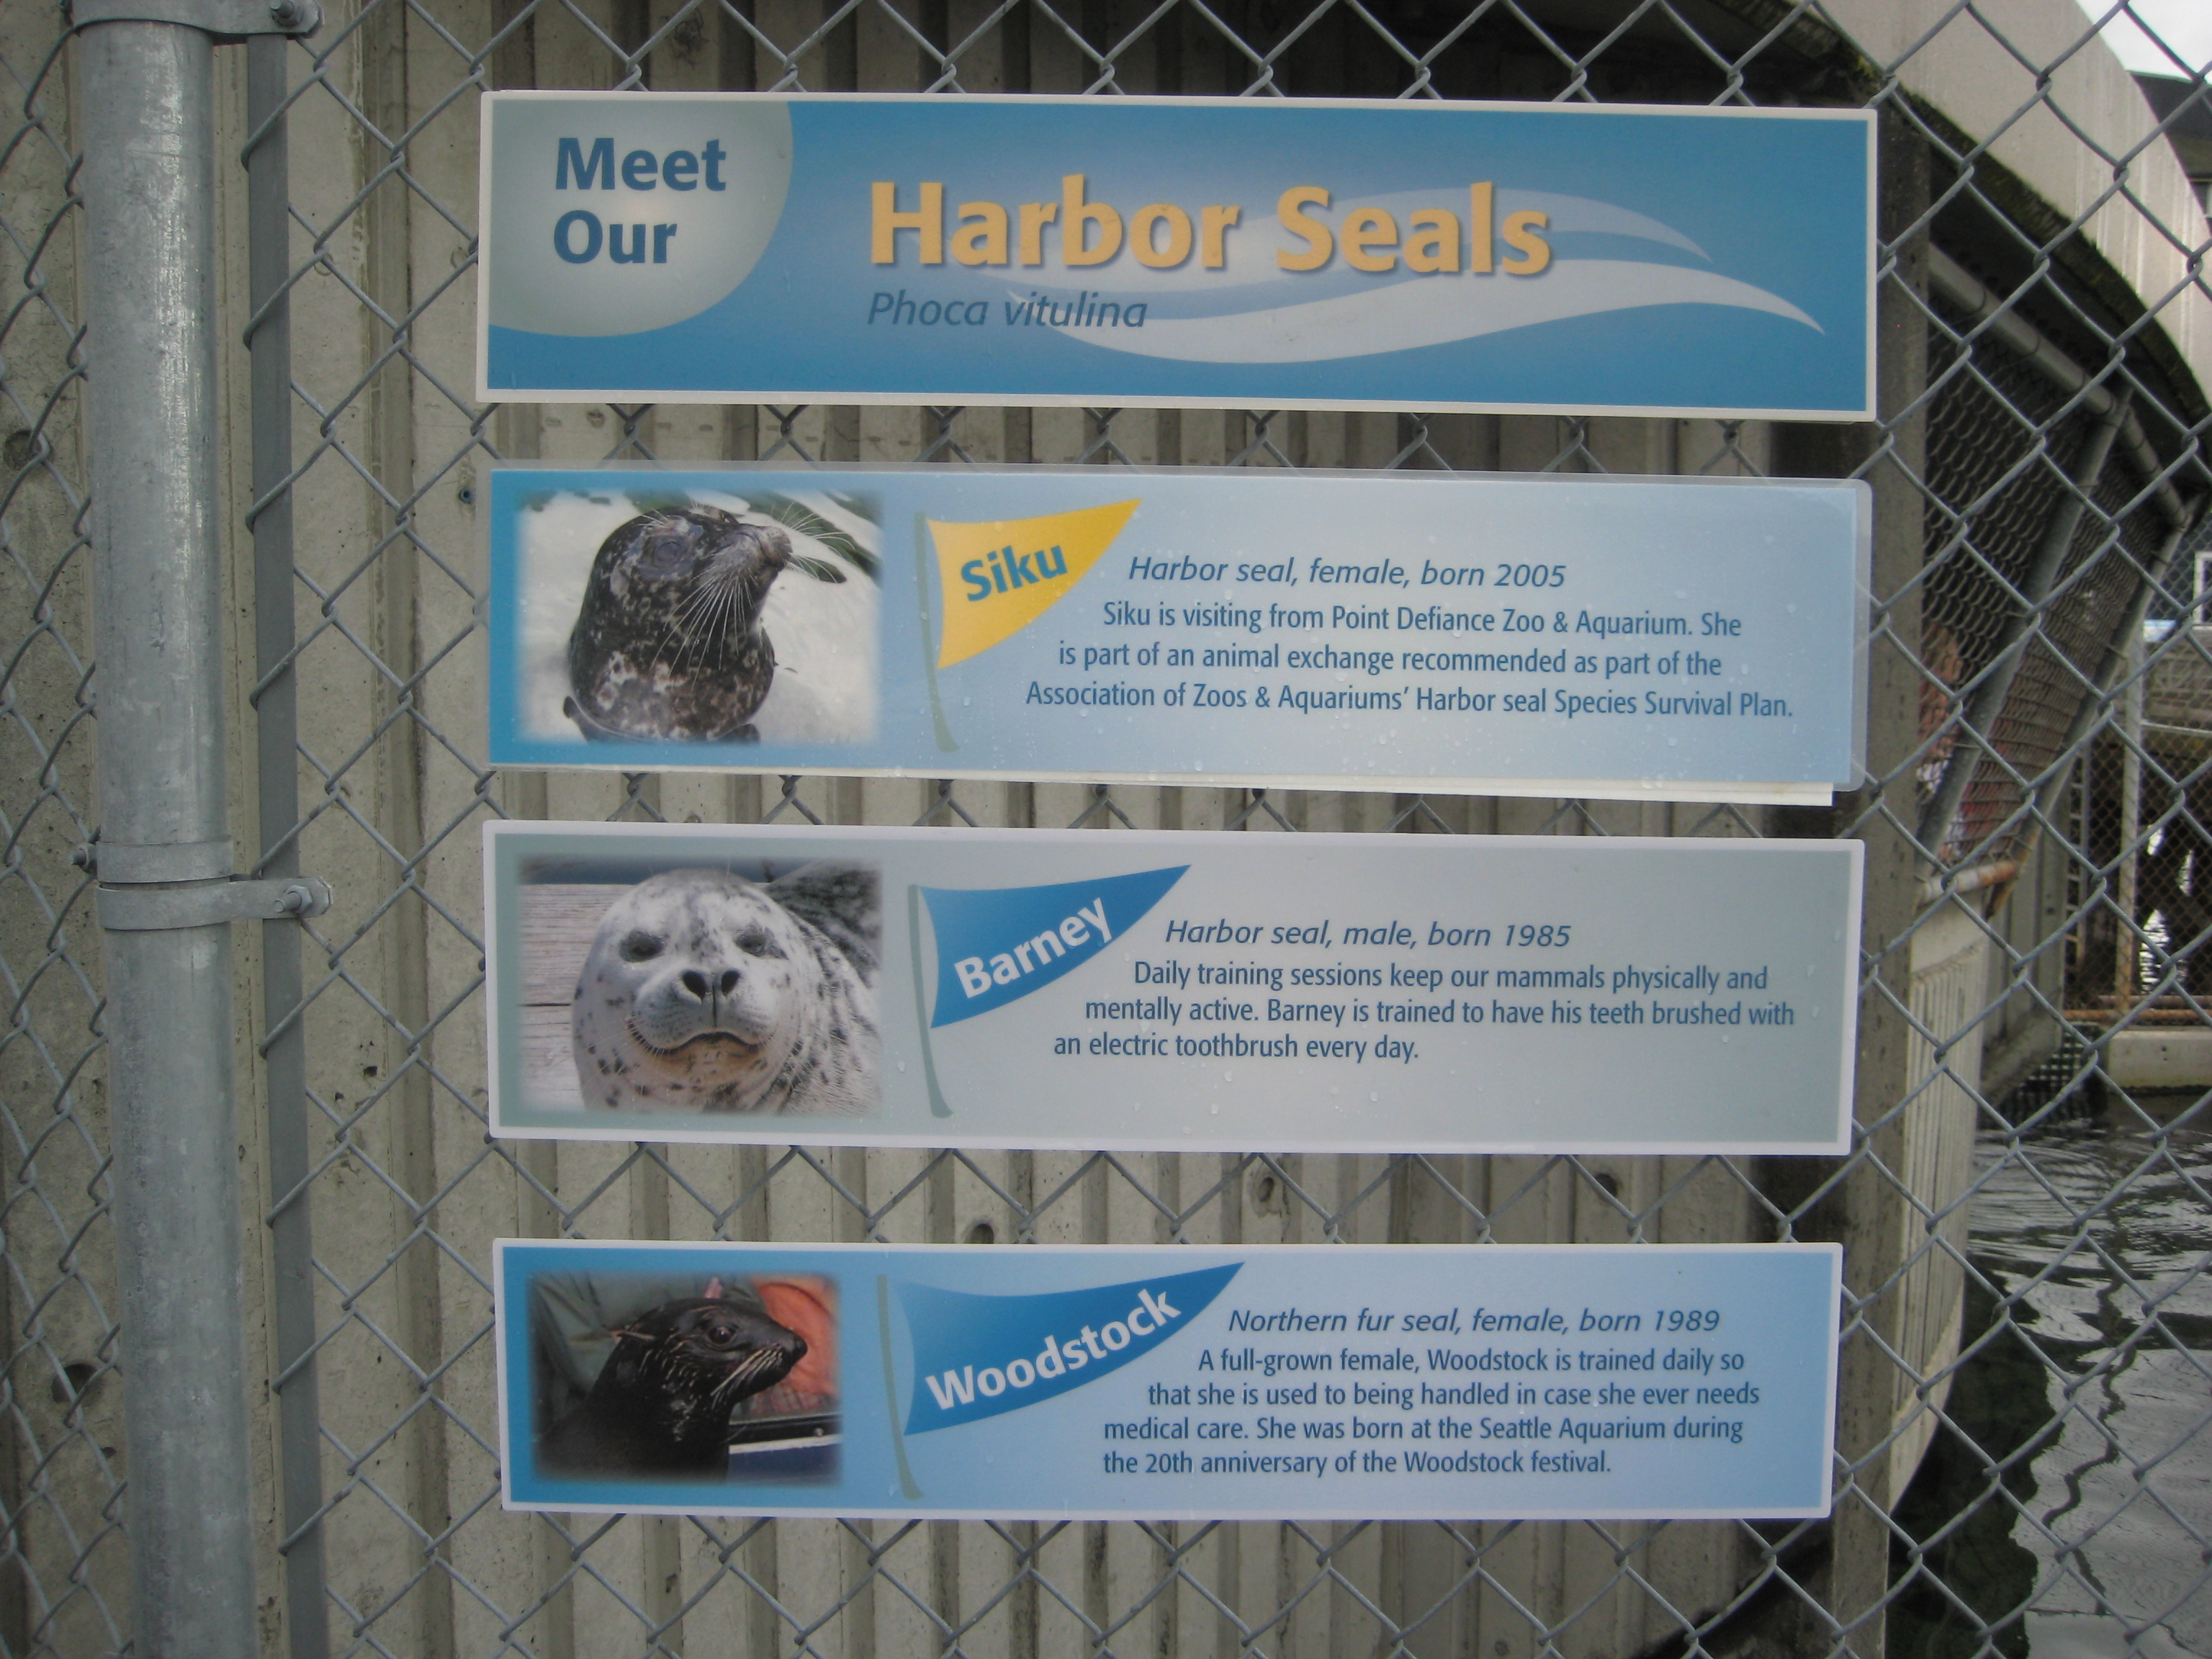

Ten individuals/groups were observed reading the Meet Our Harbor Seals sign featuring Barney, Q, and Woodstock.
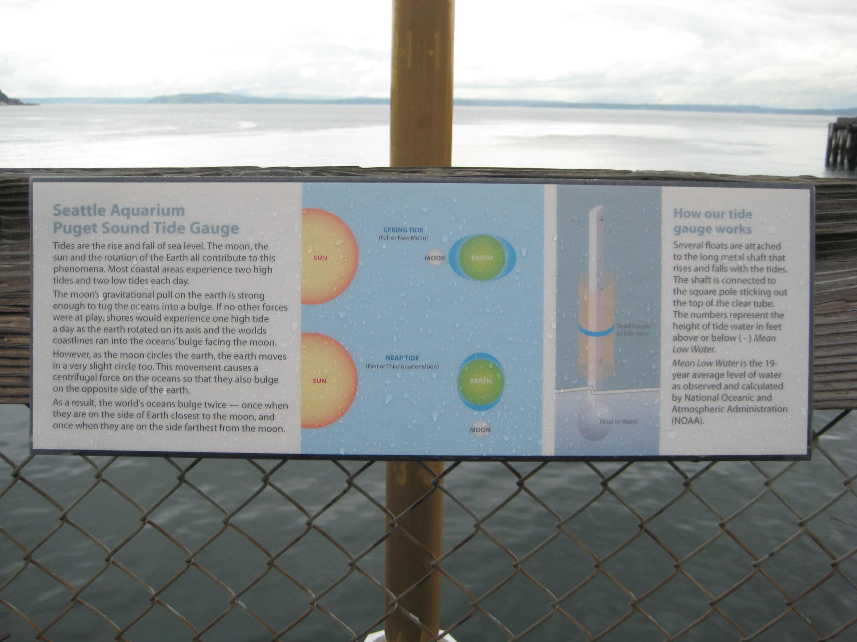

No visitors were observed reading the sign about the Puget Sound Tide Gauge on the finger pier.

Reflective Tracking
The reflective tracking map (instrument included in Appendix) was used to facilitate free-form conversations with visitors about what they remembered seeing and doing on their path up the ramp from the Family Orca Center. Rather than viewing the coded data as a singular data set, several themes were extracted and analyzed separately.
The first data set comes from indications visitors made on our map of where they remembered stopping. The second shows comments made about the exterior area.

Visitors mentioned several actions that they took while traveling through the harbor seal area.

Since instances of visitor interaction with signage were of particular interest to the client, instances of conversations that include signage are included in the chart below.

Visitors also talked about what they remembered seeing or not seeing. In these instances, data collectors generally followed up with questions about specific areas of the exhibit.

Discussion
Demographics
About two-thirds of participants responded that they had been to the Seattle Aquarium before although only 50% reported having seen the harbor seal habitat. This suggests that the area in question may be missed by many visitors, even those familiar with the institution. We asked if visitors had seen a marine mammal presentation previously and about one-fifth (22%) reported that they had although less than half of those could recall which specific presentation. Asking whether participants in the whiteboard activity had prior knowledge of harbor seals, yielded mixed results. Most often they reported knowing about the seals because of seeing them in media such as television, movies, books and the internet. We did not speak with anyone reporting being a biologist, researcher, professor, or scuba diver.
Visitor Knowledge (whiteboard)
Of the six images we chose, two were meant to be “freebies,” Seal the singer and the group of N.A.V.Y. seals, which were included to make visitors feel more comfortable, and encourage them to engage with the activity. We included the easily identifiable male elephant seal which also proved to be a “freebie;” at least 95% of participants matched these three images correctly. Our main interest was seeing if visitors could correctly identify a harbor seal. About two-thirds did. The other thirds of responses were split between the fur seal and the sea lion, with slightly more choosing (or guessing as most did when they got the identification wrong) the fur seal. As the harbor seal is very common in the Pacific Northwest and the Aquarium also features fur seals, we believe there is the potential for many more visitors to be aware of the differences between the two species.
The following facts, identified by Aquarium staff as specifics mentioned in harbor seal exhibit panels and Marine Mammal presentations, were familiar (answered correctly by more than 60% of visitors) to respondents:
Harbor seals “haul out” to bask in the sun (90% correct).
Harbor seals are the most common local marine mammal (66% correct).
Baby harbor seals are protected by law (64% correct).
The spots on their fur provide camouflage. (64% correct).
Harbor seals have claws (62% correct).
Fur keeps harbor seals warm (61% correct).
Five of the facts identified by Aquarium staff as part of the current harbor seal interpretive material were not familiar (answered correctly by less than 40% of visitors)
Harbor seals are omnivores (eat both plants and meat) (54% correct).
Harbor seals don’t chew their food (53% correct).
Harbor seals only live in the Pacific Ocean (41% correct).
Harbor seals have exterior ears (29% correct).
Harbor seals bark to communicate (17% correct).
This suggests that visitors are less familiar with the anatomical features that differentiate harbor seals from other species of seals. Visitors are also less familiar with harbor seal diet and eating habits. These categories of information could be elaborated on in interpretive material in the new exhibit, as well as in future Marine Mammal presentations.
Visitor Interests (survey)
Visitors were most interested in learning about harbor seal behavior generally. The next most popular categories were the stories of Barney and Q specifically as well as their habitat and how and why the Aquarium trains them. Though some categories were more popular than others, there was interest expressed in all nine provided categories. Blanks were provided for participants to suggest things that they were interested though no one used them.
Use of current exhibit (timing and tracking)
Analysis of the Timing and Tracking instrument resulted in the identification of five pathways visitors used when encountering the harbor seal exhibit. These pathways are identified by point of entry as follows:
Straight Through: Visitors enter from the Family Orca Center and walk along the hallway without stopping to view the harbor seals.
Hallway Only: Visitors enter from the Family Orca Center and walk along the hallway, exiting towards the sea otters. In this pathway, visitors do not go outside onto the pier, but they do stop.
Hallway, Went Outside: Visitors enter from the Family Orca Center, walk along the hallway and detour to the exterior of the harbor seal area before continuing on towards sea otters.
From Finger Pier: Visitors start out at the exterior of the exhibit having walked north along the finger pier. They then exit by many pathways.
From Otters: Visitors enter from the otter area, counter to typical hallway flow.
15.6% of observed visitors walked straight up the hallway, and did not stop at the harbor seal exhibit. The median time for this direct pathway was 8 seconds. 31.2% of observed visitors stopped and viewed the exhibit from the interior hallway only. The median time spent in the exhibit on this pathway was 50.14 seconds, the least of the various pathways visitors took to encounter the exhibit.
The pathway that resulted in the longest median time spent in the exhibit was “Hallway, Went Outside.” The median time for visitors who used this pathway was 2 minutes and 12 seconds. One-third (33.6%) of visitors utilized this pathway. This suggests that when visitors are encouraged to visit both the inside and outside harbor seal viewing areas, they spend more time observing the animals and engaging exhibit content.
Reading signs
Of the 128 timing and tracking instruments, only 15 (or 11.7%) included instances where individuals were observed reading exhibit signage. Of the four signs included in the harbor seal exhibit, the most-looked at was the sign including information about Barney and Q (the seals on display during data collection). The relative popularity of this sign aligns with information collected with the Whiteboard Knowledge Instrument, where visitors reported being most interested in the Story of Barney and Q.
What visitors remember/talk about (reflective tracking)
Conversations with visitors were generally free-form though data collectors were instructed to use their discretion in providing talking points. Major themes that were encouraged in general were where visitors remembered stopping, what they remembered doing and what they remembered seeing. Marks that visitors made on the maps indicating stops roughly corresponded with what we collected during timing and tracking: most stops were made inside, followed by those made just outside the door on the north side of the deck and the least were made on the long portion of the finger pier facing west. When visitors talked about the exterior area they most often mentioned not going out either because it was cold and rainy or that they were unsure if they could go out. Positive comments centered on the view of the surrounding area and the multiple perspectives from which the seals could be viewed.
Some participants (20) remarked that they did not see or know about the harbor seals. Fewer (9) said that they stopped or went outside because there was a feeding/mammal talk going. Seven participants reported taking photos. A large majority of activity-based conversation was centered on interpretive signage. This category was broken down further and the majority (29 of 49) of those comments were visitors saying that they did not read any signs. Additionally, three said that they did not remember seeing any signs at all. One person wanted to see more signs in the harbor seal area.
Visibility was a hot topic as well. Most comments regarding what visitors saw were regarding the physical height of the viewing window (14). Many parents with small children reported having to hold their toddlers ups to see and one visitor in a wheelchair was unable to view the seals through the interior window at all. Still, almost as many (13) delightedly reported seeing one or more animals hauled out or that they saw multiple seals in the tank (10). The next most popular comments were both requests: to have an underwater view (9) and to remove the chain link fence (7). Visitor wants were varied and often referred to potential upgrades for the physical space. They wanted to see more room for the seals and a more naturalistic habitat. For their own comfort, participants requested more benches, more shelter and more tactile elements (the carved otter bench was mentioned a couple times). After learning that there were exterior viewing opportunities one visitor hoped the remodel would include a more obvious door to the exterior area.
Limitations
Time of year
Data was collected in February 2012. Winter is not a peak season for the Aquarium, so the amount of instruments collected is not indicative of typical Aquarium attendance throughout the year. The often cold, sometimes wet weather may have deterred visitors from exploring the harbor seal area more thoroughly than they might in the summer. Additionally the unexpected birth of a new sea otter sent many visitors hurrying up the ramp without stopping. If a follow up study were to be conducted, collecting data again in the winter would provide the most comparable set of results.
Many data collectors
As this project is part of a learning exercise for both first and second year graduate students, we had a large number (10) of quickly trained data collectors. That may have introduced some variability in the content and quality of results recorded, especially for open-ended qualitative questions. Being able to record large amounts of subjective material takes practice and the most time that any student would have spent with each instrument was five hours – for those who tried out different instruments the time spent with each would have been less. Still, with our combined efforts, over 100 hours were spent gathering visitor input.
Conclusion
Implications for Seattle Aquarium
Comments provided by visitors, along with observations of their current use of the space support the need for a renovation of the harbor seal habitat. Data collected also suggests that current plans for the renovations align with visitor comments and support the opportunities listed below.
Opportunities – Visitor Knowledge
- Visitors are interested in learning more about harbor seal behavior, specific information about the lives of Barney and Q, as well as more about how and why visitors are trained.
- Many visitors were unfamiliar with the details of harbor seal diet and feeding habits, as well as specific anatomical features that distinguish harbor seals from other species.
- More information about differences between species of marine mammals on display at the Seattle Aquarium.
  - A significant amount of visitors (22%) misidentified a harbor seal as a fur seal. Similarly, 22% of visitors thought the fur seal was a harbor seal. (The answers were not necessarily swapped equally). Since these are the two species of pinniped on display at the Aquarium, there are opportunities to continue education related to the differences in these species.
Opportunities – For Future Exhibit
- More transparent or direct connection between the interior and exterior viewing areas.
  - Observations showed that visitors are more engaged and spend more time in the exhibit when they explored both the interior and exterior of the exhibit.
- Increased signage visibility
  - Relocating exhibit signage, especially the which is located in a corner where it is out of direct line of sight for the visitor, could result in more instances of visitor engagement
- Increasing visibility of animals
  - Many visitors (14) indicated the desire for increased viewing opportunities by lowering the window and seven suggested removing the chain link fence. An additional nine requested underwater views.
  - Visitors with young children and those using wheelchairs frequently described the animals as being difficult or impossible to see.
Opportunities for Future Research
We recommend that the Aquarium conduct a summative evaluation using the same (or similar instruments) to be conducted in the winter of 2014. By using this evaluation as a baseline, a summative study would illustrate the success at improving visitor experiences in the harbor seal exhibit.

Research Team
Project PIs
Chris Cadenhead
Katie Phelps
Project Support
Nick Visscher, University of Washington Museology Graduate Program
April Troka, Seattle Aquarium
Angie Ong, Pacific Science Center

Acknowledgements
Special thanks to our first year data collectors, without whose assistance we could not have completed this project: Anna Braden, Ari Einbinder, Danielle Acheampong, Dylan High, Ellie Kleinwort, Katharine Canning, Lissa Kramer, Megan Earls, Megan Jablonski, and Niki Ohlandt.

Works Cited
Bitgood, Stephen. The ABCs of Label Design. Visitor studies: Theory, research, and practice, Vol. 3. Jacksonville, AL: Center for Social Design. 1990.
Randi Korn & Associates. Monterey Bay Aquarium, Sharks and Rays Exhibition, Front- End Evaluation. 2002.
Serrell & Associates. Infection Connection. Liberty Science Center. 2002. Accessed October 14, 2011. http://informalscience.org/evaluation/show/40
Serrell & Associates. A Front-end Evaluation on Invasive Species for the Florida Aquarium. 2001. Accessed October 14, 2011. http://informalscience.org/evaluations/report_94.pdf
Woolner, Pamela, Jill Clark, Elaine Hall, Lucy Tiplady, Ulrike Thomas, and Kate Wall. Pictures are necessary but not sufficient: Using a range of visual methods to engage users about school design. Learning Environments Research. 2010.

Other Helpful Resources
Creswell, John W. Research Design: Qualitative, Quantitative, and Mixed Methods Approaches. 3rd ed. Thousand Oaks, CA: Sage Publications, Inc., 2009.
Diamond, Judy. Practical Evaluation Guide: Tools for Museums and Other Informal Education Settings. Lanham: Altamira Press, 2009.
Serrell, Beverly. Paying Attention: Visitors and Museum Exhibitions. Washington DC: American Association of Museums, Technical Information Services, 1998.

APPENDIX
Magnetic Whiteboard Instrument
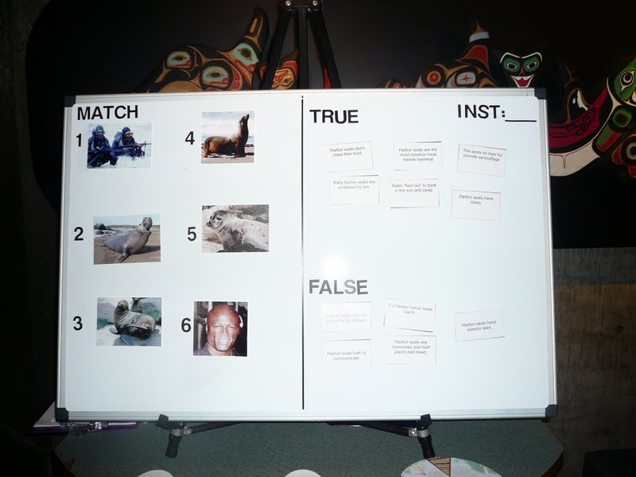
Survey – Visitor Interests side
Survey – Demographics side
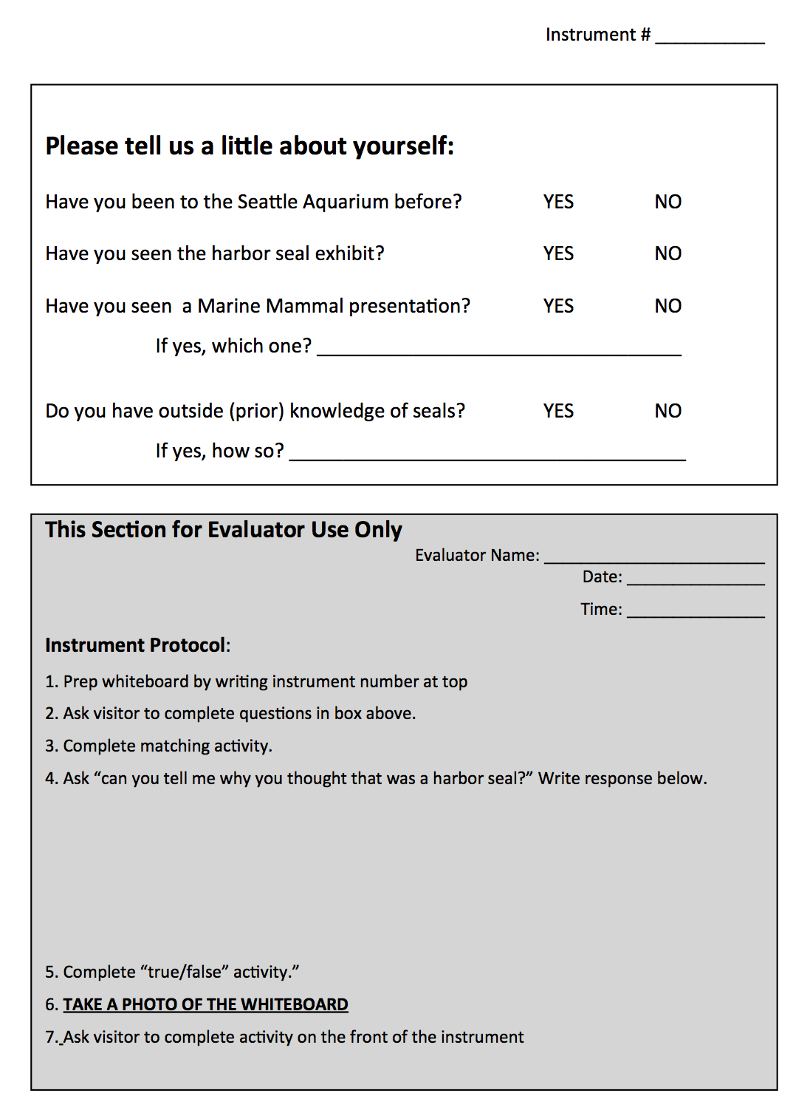
Whiteboard activity Protocol (double check that board and paper #’s match)
Say something like:
Hi! Would you mind helping me with an activity real quick? The first part is matching the photos of the seals with their names down here. [do activity, make small talk]
thanks. For the second part we have a bunch of facts about harbor seals. Could you put all the ones you think are true up here and the false ones down here? If you are unsure of anything feel free to just leave it on the table. [do activity, Small talk to get answers to demographic questions]
Great. So the reason we are doing this is that the aquarium is remodeling the harbor seal area upstairs and they want to find out what you guys are most interested in seeing in the new exhibit. Would you mind circling the three things that are of most interest to you and your family/group? [hand them clipboard and pencil, photograph board]
That’s it. Thanks so much!
When to mark incomplete:
People may do the matching and then not want to stick around for the true/false part (or assume it is too hard for their kid). That’s okay.
Before they go ask them the demographic questions (you may have already learned the answers) and see if they will chose 3 of the areas of interest.
When to mark no:
If you have definitely asked them to participate and they decline. Write “no” on an instrument and if you can, give a reason why like “not interested” “in a hurry” “child ran off.”
If you are just saying hello or directing them to the baby otter and they walk off that is not a no (rejection).
Double check that board and paper #’s match.
Timing and Tracking
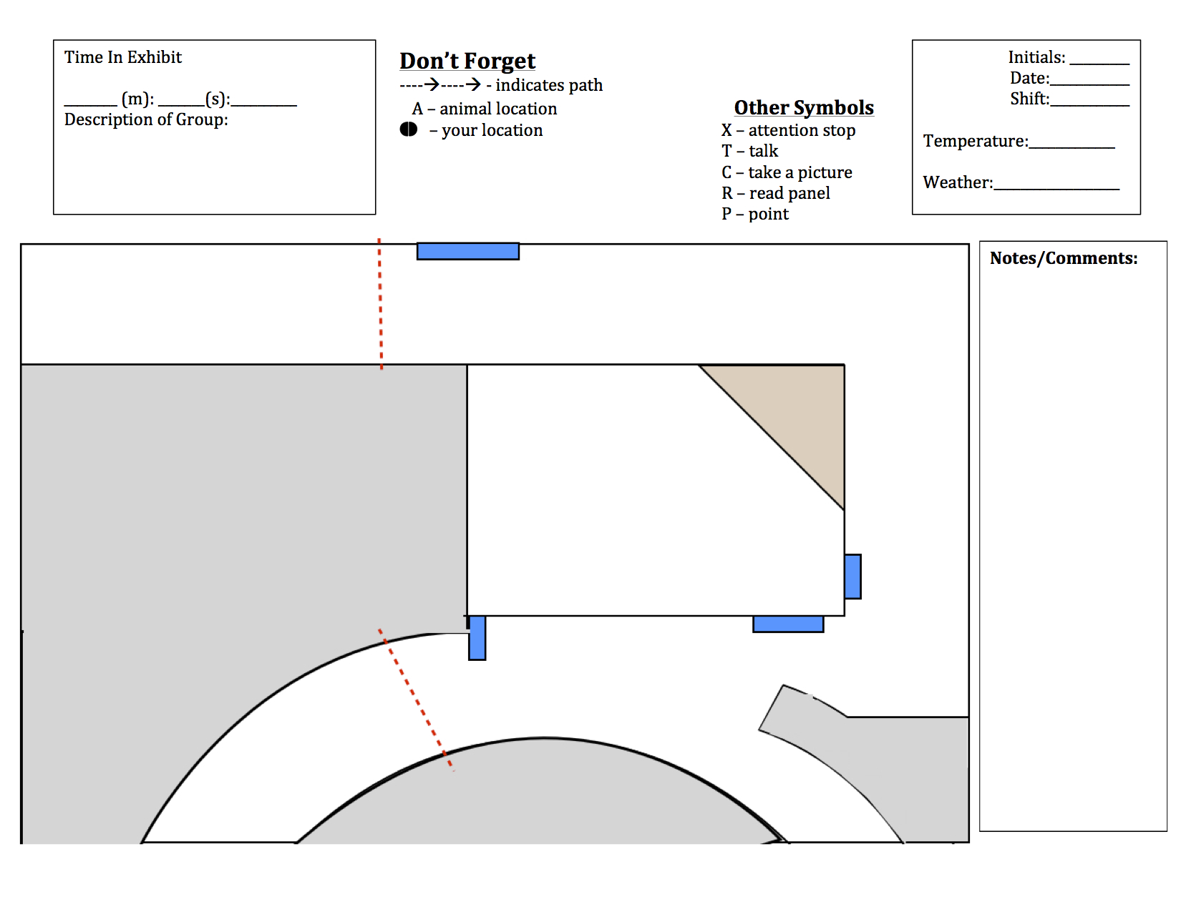

Timing & tracking protocol
Be sure the timer starts at zero. If someone leaves the area for a second and comes back, restart the timer if you haven’t cleared it or write down the second time as well. We’ll do the math later.
mark where the living things are: you (a dot), the animals (“a”),
the visitor/group (an arrow). Add other symbols at each stop, if applicable.
Sometimes people walk through very fast (like, 6 to 8 seconds fast). That’s okay.
Brief demographics are fine (# adults, # children).
Track only one group at a time. Even if you think you are missing a really “good” group. We will have plenty of these by the end.
It may be easier to fill out the “conditions” box at the end of your shift or in chunks. Do whatever works for you; just don’t forget and don’t pre-fill them out.

Reflective Tracking
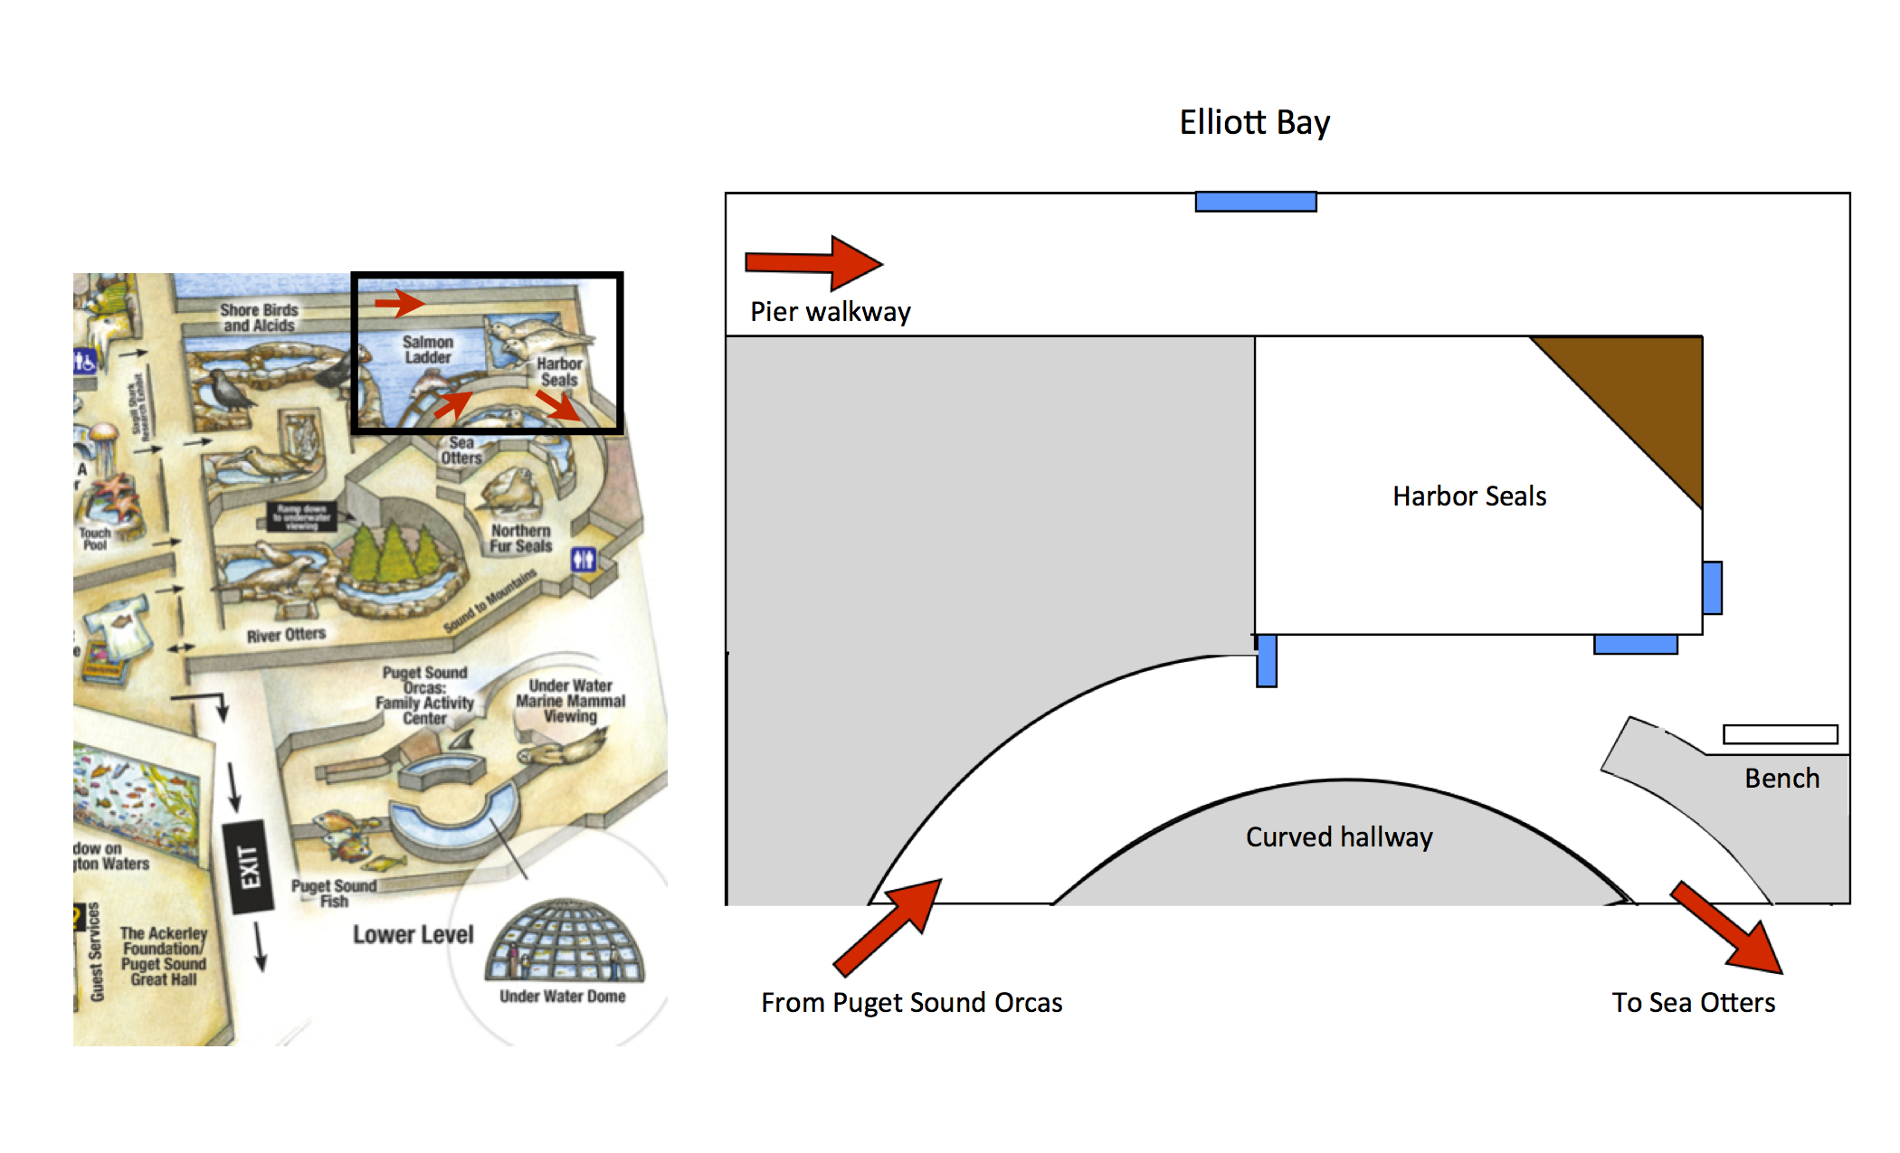
Reflective map protocol
Don’t be intimidated. Most People seem to like this instrument. Explain that the aquarium is remodeling and wants to know how people use the space.
If the participant doesn’t take the clipboard and pencil, that’s okay.
Draw for them and ask some leading questions like “did you walk up or down the ramp?” “Did you see the seal tank?” “Did you stop to look in?” “Did you take a picture or point at something?” “Did you go outside?” “What else do you remember?”
If they go on and on, rad! Take brief notes and make them feel welcome.
If the lines and notes are messy or hard to read, feel free to clean them up. You’ll never remember what you meant to say later on.
Check out the baby otter before the end of your shift. :D

