Harbor Seal Talks at the
Seattle Aquarium:
An Exploratory Evaluation

New Directions Project
Spring 2012
Research Team: Colleen Lenahan, Hal Kramer, Lissa Kramer
Report reviewed by Nick Visscher

Executive Summary:
Our project for the Seattle Aquarium was to complete an exploratory evaluation of the Harbor Seal Talks, an element of the Marine Mammal Talks programming. These talks are conducted by either staff biologists speaking from within the seal enclosure or by “dryside” interpretive staff speaking from the audience in dialogue with the biologists. This evaluation was requested by the Interpretation Department to ascertain what the general content of the talks is currently, whether specific conservation messages are being transmitted, and how engaged audiences are in the talks. Our study found that the content of the talks varies widely but remains under the umbrella of three general themes, that conservation messages are inconsistently delivered but are received by audiences when available, and that the audience is engaged in and generally positive about the harbor seal talks.
Key findings of our study are based out of the above-mentioned results. The three prominent themes of the talks are: both biologists and dryside interpreters emphasize the differences between harbor seals and northern fur seals, biologists consistently also emphasize the use of training for the health and well being of the seals, and conservation messages are more likely to be delivered to audiences when a dryside interpreter is present. Another key finding that is closely related to thematic messages is that when conservation messages are presented, audiences do receive them and are able to describe what they heard. Interestingly, only one of the two conservation messages mentioned by the Aquarium as intended messaging was delivered, that of the need to leave harbor seal pups alone when found on the beach. Instead of the other intended conservation message, that harbor seals are a barometer of the health of the Puget Sound, we found an unintended message was frequently mentioned, that of buying and consuming sustainable seafood. The study also produced unintended results, such as the discovery that talks are more heavily attended in the afternoons. This information could be useful for the Aquarium’s program planning in the future.

Introduction:
Project Background:
The site of our project was the Seattle Aquarium, located on the waterfront in downtown Seattle. The Aquarium exhibits both local Puget Sound species and some tropical species, mostly collected from Hawaii. Our evaluation focuses on the harbor seal exhibit, one of the marine mammal exhibits at the Aquarium. Other marine mammal exhibits include fur seals, river otters, and sea otters in addition to the harbor seals. The Aquarium offers two harbor seal talks per day, one at 11:30 am and one at 2:00 pm, each scheduled to last approximately 10 minutes. They may be given by either a biologist inside the enclosure with the seals, or a dry-side interpreter standing with the audience on the docks while in dialogue with a biologist working in the enclosure. The Aquarium requested that we evaluate the harbor seal talks for total content, conservation messaging, and the extent of visitor engagement with the talks. The target audience for the talks is the general audience of the Aquarium.
This exploratory study was conducted under the guidance of Nick Visscher, coordinator for the University of Washington Museology Graduate program’s Audience Evaluation Directed Fieldwork as a component of the New Directions project. New Directions is an IMLS funded project designed to train museum studies graduate students to understand, support, and engage in audience research. A key component of the training is using museums as learning laboratories where students work with an institution to conduct audience research, under the guidance of evaluation mentors and support staff.
Purpose Statement:
The purpose of our study was to evaluate the content of the harbor seal talks and verify audience engagement. The evaluation focused on the visitors' responses during the talks, if the intended conservation message was understood by the audience and clearly conveyed by the interpreters/biologists, and measured the visitors' affinity towards the Aquarium after attending the talk. The significance of this evaluation was to help the Aquarium to better understand the content of the messaging of the harbor seal talks and to measure support of harbor seals and the Aquarium. The Aquarium intends to expand the harbor seal exhibit and the main building and hopes that the harbor seal talks will serve to strengthen advocacy for these projects. In order to conduct this evaluation, we observed what the Aquarium personnel did and said during the talk, observed how the visitors react physically and verbally during the talk, and followed up with visitors after the talk to see what they took away from the experience.
This evaluation is formative and designed to inform the Aquarium of the consistency of content of a current program for possible further evaluation. Currently, the Aquarium’s Interpretation Department is unsure of the overall content and messaging that visitors receive and what their response to the talks is.
Our evaluation questions were formed under the direction of Aquarium staff. The Aquarium was interested in evaluating several components of the harbor seal talks, but due to the wide-ranging nature of these interests and the brief duration of our study, we streamlined our research area to three areas prioritized by Aquarium staff.
Evaluation Questions (directed by Seattle Aquarium):
EQ1: Do visitors who attend the talks receive any information related to conservation messaging?
qi: Do visitors hear a conservation message?
qii: If so, what is it?
EQ2: What messages/information are being brought up consistently?
qi: How many times is specific messaging brought up?
qii: What are the differences between biologist-narrated talks and biologist and interpreter-facilitated talks?
EQ3: What is the current nature of visitor engagement during harbor seal talks?
qi: How many questions are asked?
qii: What are questions typically about?
qiii: What is the extent of dialogue between presenter/audience?
qiv: Did the visitor find the experience enjoyable?

Literature Review:
As part of our planning process, we reviewed similar studies and evaluation education materials to help us select and create appropriate tools for our study. We relied on two texts to inform our methodology of nonparticipant observation and tools for conducting it: Jack R. Fraenkel & Norman E. Wallen’s seminal work, How to Design and Evaluate Research in Education, 7th Ed. and Bella Martin & Bruce Hanington’s text Universal Methods of Design.
Fraenkel & Wallen recommends nonparticipant behavior observation, where the researcher sits on the sideline and watches the activity, as an ethical and minimally intrusive method of research gathering (441). Further, the type of observation we conducted is a naturalistic observation, one that allows the researcher to collect information without manipulating variables. While this type of data collection does produce an observer effect because the presenters and audience may have noticed that they were being filmed or watched by data collectors, it can still generate information that leads to broad patterns. The longer the data is collected, the more accurate the patterns are. In this case, because the presenters were observed over 11 talks, Fraenkel and Wallen’s work suggests that the presenters became accustomed to being observed, thus mitigating the observer effect on the content of their presentations.
Both Fraenkel & Wallen and Martin & Hanington suggest using behavioral observation checklists and some form of technology for recording the behavior we wished to study to enable accuracy through triangulation and repetition of viewing the behaviors for more consistent coding and credible analysis. Martin & Hanington also discussed using pilot studies to generate which behaviors would be included on the initial checklist while still creating space to add behaviors that may occur less frequently but are still relevant (120). The authors envision this as including an “other category” on the behavioral observation checklist. Additonally, Martin & Hanington support using a survey or questionnaire as a follow-up tool to a behavioral observation checklist. They state that “inferences can be verified through [sic] questions with participants during or following observation”.
One similar study we looked at was conducted by the Monterey Bay Aquarium to evaluate the effectiveness of their training program for volunteers who present sea otter interpretive talks (Mortan, 2011). Evaluator Simone Mortan used film analysis of the interpretive talks and focus groups of audience members and volunteers to research both how effective the presenters felt they were being and how much the audience was taking away from the talks. While this study was not an exact model for our evaluation of content, it was illustrative of how to effectively conduct film analysis. Because we lacked the time to complete post-talk focus groups with audience members and presenters, we opted for audience surveys to gage an exploratory (not definitive) audience engagement response. Based on Mortan’s use of and the effectiveness of focus groups, we feel this could be a component for future study of audience satisfaction and learning from the harbor seal talks.
Methods:
We attended and filmed one general marine mammal talk and one harbor seal talk to pilot test our three instruments prior to data collection for our study. The tools we were testing were our film method, a behavioral observation checklist and an audience questionnaire with both open and closed questions. This testing allowed us to create a base list of behaviors for our checklist and to reformat questions on our audience questionnaire for clarity and intent. For our actual study, we attended and filmed 11 harbor seal talks, with data collectors standing in the audience to complete the behavioral checklists during the presentations and for gathering audience questionnaires. These tools are attached as the behavioral observation checklist (Appendix I), and the self-administered audience questionnaire (Appendix II). Our intent had been to attend and analyze data from an equal number of biologist presentations as from dryside interpreter-biologist dialogue presentations. Initially, the 11:30 am talks were scheduled to be biologist-only talks and the 2:00 pm talks were scheduled to be facilitated by a dry-side interpreter. Presentations, however, did not follow this schedule; there were interpreters at some morning talks and biologists only at some afternoon talks. Despite shifting presentation styles, we were still able to collect data from 5 biologist only presentations and 6 dryside interpreter-biologist dialogue presentations.
Filming was done from two vantages dependent on weather; the point of broadest camera angle was from the docks on the south side of the seal enclosure just past the “audience zone”, but was exposed to weather such as wind and rain which could deplete sound quality and expose our camera to adverse moisture. All but two talks were filmed from this point while the remaining two were filmed from under the roofed portion of the enclosure. While this had increased protection from the elements, it had markedly reduced audio quality and a slightly narrowed camera angle. Films were then downloaded for later transcription and analysis.
While filming, data collectors also completed our second tool, behavioral observation checklists. We were able to collect 1-3 behavioral observation checklists from each talk, one per data collector present.
Following each presentation, data collectors stopped filming and completing behavioral observation checklists and provided the audience with self-administered questionnaires. This process was limited by a few factors. The space surrounding the harbor seal enclosure does not lend itself well to writing; there are no benches or flat surfaces on which to write except for the provided clipboards and if it was raining, the questionnaires became damp for use with pens. Visitors also exited rapidly from the harbor seal exhibit area due to its multiple points of departure; it was difficult to approach more than one or two audience members per data collector per talk before the audience had entirely dispersed. Despite these limitations, we were able to collect 33 questionnaires, exceeding our pre-determined goal of 30.

Process Overview:
Sample size: 11 talks filmed and observed, 33 questionnaires gathered.
Sampling method: Convenience sampling. Behavior sampling (observation).
Analysis plan: Frequency calculated by SPSS and cross tabulation of behavioral checklists between biologist talks and biologist with interpreter talks. Content analysis of film reviews.
Communications plan: Our results were presented publicly at a symposium held by the UW Audience Research Directed Fieldwork group at the Henry Art Gallery at 1:30pm, June 6, 2012. We used Prezi online software to deliver our results with all team members facilitating. Members of all Fieldwork teams were present and client institutions were invited to attend. Museology Graduate Program Director, Kris Morrissey, also attended the symposium. Our completed report will be given to our Seattle Aquarium project contact and interpretive staff supervisor, Heidi Ebel.
Initial data analysis notes:
- It seems like the longer the talk, the more engaged people were (check against surveys of people saying how long it felt)
- seals are less active in rain; people were therefore less engaged
- 4 out of 11 talks covered a conservation message
- of the 4 talks that did cover conservation messages, 3 of them reported it in the visitor surveys
Results
Film Content Analysis:
The films for each talk were viewed, transcribed, and analyzed for content. Three prominent themes emerged: all talks emphasized the difference between harbor seals and northern fur seals, biologists tended to also emphasize that the training activities the audience was observing were for the animals’ health and longevity, and that conservation messages were more frequently delivered when a dryside interpreter was present.
The differences between harbor seals and northern fur seals represents the majority of content included in all harbor seal talks, regardless of the individual presenter or whether there was a biologist only versus biologist-dryside interpreter dialogue. The most commonly presented information was a demonstration of how each species moves on land and in water, and pointing out the differences between the physiology of each species ears and flippers. Biologists also varied this aspect of the talk by including different details per talk, such as one talk included information specific to harbor seals versus northern fur seals whiskers while another talk developed details about how each species keeps warm (thick blubber versus thick fur). Dryside interpreters frequently included broad conceptual information such as species genetic information and theories of evolution.
In all talks, biologists mentioned some aspect of training the seals of both species for their own health and well-being. Comparisons with training pets were frequently utilized to relate training behaviors to audience members’ own experiences. Backing a seal in and out of a cage occurred frequently with an explanation that it was to reduce trauma if the seals ever need to be moved. Using targets for feeding and for water acrobatics was almost always accompanied by an explanation that these training methods allowed for brushing the seals’ teeth, giving eye drops, or for taking voluntary blood draws. It was also common for biologists to mention that these seals have their own dentist and ophthalmologist.
We were directed to evaluate the consistency of conservation messages, explicitly of two messages. During talks when dryside interpreters were present, conservation messages were delivered more frequently than when they were not. The messages were either directly provided by the dryside interpreter or delivered as a component of the dialogue between the dryside interpreter and the biologist. The first message for which we checked was that harbor seals are a barometer of the health of the Puget Sound. The second message for which we checked was that of leaving harbor seal pups found on the beach alone; the pups are most likely not abandoned and approaching them is detrimental to their well being. No biologist only talks contained any conservation messages. Of the six talks we analyzed that had dryside interpreters present, no talks contained the first message and four talks contained the second. Interestingly, four talks with dryside interpreters present noted an additional conservation message that the Aquarium had not said was being targeted; when both dryside interpreters and biologists were present, either would mention that the seals were being fed restaurant-quality, sustainably harvested seafood. This content was accompanied by an action message that audience members could pick up a SeaWatch Card (developed by the Monterey Bay Aquarium) at the Seattle Aquarium to help visitors eat sustainably for healthy oceans.

Fig. 1 Content of harbor seal talks based on film analysis
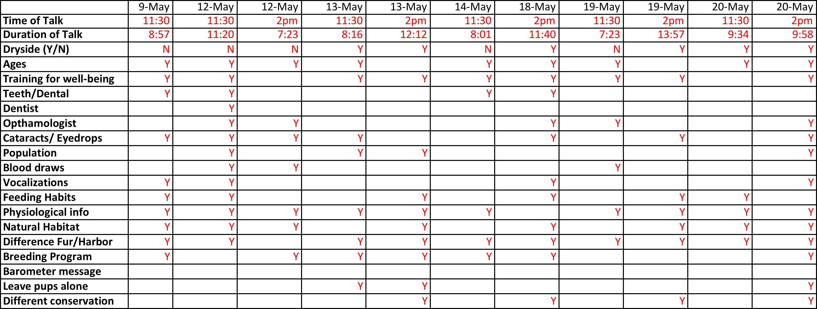
Open-Ended Question Analysis:
On our visitor questionnaires, we included three open-ended questions in order to give visitors an opportunity to expand on their reactions to the talk and to gauge whether or not visitors were retaining the conservation messages without actively prompting them with a closed-ended question. The three open-ended questions used were: “#5: What did you learn about Harbor Seals and how they fit into the Puget Sound environment during today’s talk, if anything?” “#6: How do you feel about Harbor Seals after the talk?”; and “#7: Any other comments or questions about the Harbor Seal talk? List them below.”
Visitors who completed the questionnaire frequently completed it in its entirety. Of the 33 questionnaires collected from visitors, 24 reported learning something in response to Question 5, 31 reported their feelings about harbor seals after the talk in response to Question 6, and 16 responded with additional questions, comments, or concerns to Question 7. In general, the responses to these questions were overwhelmingly positive and indicate a high level of visitor engagement with the animals and with the talks.
Question 5, which invited visitors to elaborate on something they had learned about harbor seals and their role in the Puget Sound environment, elicited a wide variety of responses, indicating the breadth of information covered in the talks. We designed this question with the specific purpose of gauging whether or not visitors were retaining conservation messages if one was presented at the talk they attended, but we also wanted to leave it vague enough that visitors would not be force-fed the message and that visitors who attended talks where no conservation messages were conveyed would feel that they had something to contribute as well. Of the 24 questionnaires that reported learning about seals, 11 different areas of knowledge were reported: the physiology of the seals, the performative nature of seals, the natural & instinctual behavior of seals, the learned behavior of seals in captivity, the difference between harbor seals and fur seals, the feeding habits of harbor seals, the intelligence of seals, the lifespan of seals, the population size of seals, the natural habitat of harbor seals, and the conservation message about not approaching a seal pup on the beach.
Notably, the most widely reported fact learned about seals was the conservation message about seal pups on beaches, with 5 of the 24 surveys reporting this message. This number is made even more significant when we consider the fact that only 4 of the 11 talks observed mentioned the conservation message about seal pups. Of the 24 surveys that responded to Question 5, 12 of them were collected from talks where the message was mentioned, making the retention rate of the message even more significant, 5 out of 12 or 42% of those who were exposed to the message.
The next highest message reported was the physiology of the seals, with 3 surveys mentioning the hair or coat of the seals and 2 mentioning flippers or walking abilities of the seals. This is unsurprising, given that physiological traits of the seals were mentioned at all of the 11 talks.
The next highest number of surveys (4) noted simply the “fun” aspects of harbor seals: their tricks, showmanship, and how enjoyable they were to watch. Four respondents reported the natural, instinctual behaviors of the seals, as opposed to behaviors learned in captivity (3 responses). Of those 3 responses, 2 respondents specifically mentioned that they learned about seals being taught to jump in order to raise their blood pressure for blood draws.
The remaining learned facts reported were as follows: feeding habits (3), intelligence (2), lifespan (2), natural habitat (2), difference between types of seals (2), and population size (1). It should be noted that 8 of the 24 surveys that answered this question reported multiple messages, so the total number of responses when added up by category will total 33, not 24, as some surveys are counted under multiple categories.
Question 6 was answered by 31 of the 33 questionnaire respondents, with 7 categories of responses: extremely positive, positive, appreciative of the physical beauty, increased understanding, increased respect, urge to protect, and neutral or no change. There were no negative responses. 11 of the 31 responses were extremely positive, meaning that they used the word “love” or a superlative adjective to describe their feeling toward harbor seals. 6 of the 31 were positive, meaning that they expressed a less extreme, positive response to harbor seals (i.e. “I like them,” or “Pretty good”). 5 specifically mentioned how beautiful or cute the seals are. 5 surveys indicated that they had an increased understanding of or had learned more about seals as a result of the talk, while 3 indicated an increased level of admiration, appreciation, or respect. 1 survey actually mentioned a desire to protect seals after hearing the talk. 3 of the 31 reported neutral feelings or no change in their feelings toward harbor seals as a result of the talk. Overall, 28 of the 31 surveys that responded to Question 6 (or 90%) indicated positive feelings toward harbor seals following the talk. That also equates 85% of the total number of surveys collected (28/33).
Question 7 was more sporadically answered, as it was contingent on the respondent having additional feedback to give regarding the talk or the questionnaire. 16 out of 33 visitors surveyed responded to this question. Of those 16, 9 provided a positive comment about the experience, such as “Great job,” or “It was amazing!” 4 expressed gratitude for the experience. 2 visitors posed questions to the Aquarium: “Why were they doing the abdomen rub?” and “How do you know what they are saying?” One visitor remarked that they would love to be able to touch the seals. Finally, one visitor registered her outrage that seals are being bred to live in captivity in response to hearing about the breeding exchange between the Aquarium and Point Defiance Zoo. She said that caring for seals in captivity is nice if the seals are injured, but she considers it to be quite different when they are being bred solely to live in captivity. Again, as with Question 6, the responses to Question 7 were largely positive, with the exception of a few responses that were neutral or negative.
Behavioral Observation Checklist Analysis:
The behavior checklist (shown in Appendix I) tallied the physical signs of engagement the audience displayed and how frequently. The behaviors listed on the checklist were those noted as common audience behaviors during pilot testing. These paralleled behavior audience checklists from our literature review. The tool also included checkboxes to mark content the biologists/interpreters were including, but that information was analyzed in more depth in the film analysis. The behavioral observation checklists showed definitively that the audience was engaged. They were always exhibiting signs of engagement, so the key to analysis was discerning when those signs were more and potential possibilities why.
Fig. 2
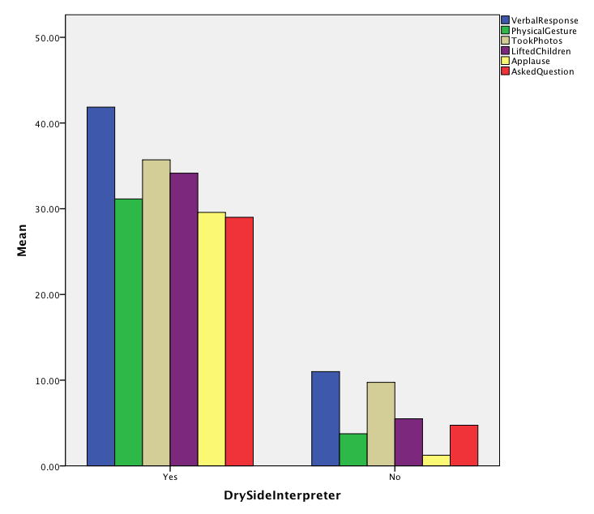 This graph shows the average amount of times there were verbal responses, physical gestures, taking photos, lifting children to see, applause, and asking questions for when there is a dry side interpreter and when there is only a biologist. The numbers explain that the audience is fundamentally more physically engaged in the Harbor Seal talks when there is a dry side interpreter present.
Fig. 3
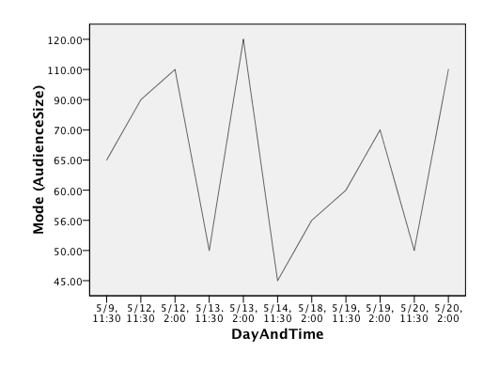This graph examines the audience size for the different days and times of the talk. Each peak of the graph is a 2 PM talk. The highest audience attendance outside of 2 PM talks was on Saturdays at the 11:30 AM talk. What this data shows us is when the largest audience can be reached. Utilizing both graphs shows how the Seattle Aquarium can get the most people engaged at one time, by at least making sure to use both dryside and biologists for the 2 PM talks.
Discussion:
Our study had some of limitations, but as an exploratory study should only be used to begin further discussion of what the Aquarium hopes to accomplish with the marine mammal talks (specifically harbor seals). We have identified three particular limitations.
One limitation previously mentioned in this report was the difficulty of garnering audience questionnaires. Because we feel this was due to the constraints of the physical space of the exhibit, we were unable to alleviate this limitation. However, with 33 questionnaires completed, we feel that the patterns that emerged from the data collected are both valid and credible.
Another limitation that we encountered was also due to the physical space of the exhibit. There was no way to observe the entire audience simultaneously. We mitigated this drawback by having multiple data collectors complete behavioral observation checklists at one time and by crosschecking those results against what was viewable from the film analysis. In this way, we feel confident that the results we obtained are the correct patterns of audience engagement that were present.
The other limitation to our study of note was scheduling conflicts for data collection. Due to the limited availability of the research team during the structured schedule of the talks, initially we were concerned that we may not be able to attend enough talks to discern usable patterns. Working with Aquarium staff, we were able to circumvent this issue. As an exploratory evaluation, our collection schedule of 11 interpretive talks and garnering of 33 audience questionnaires is sufficient to make baseline determinations regarding our evaluation goals. For future evaluations, however, it would be best to determine a greater length of data collection time to allow for a more detailed examination of objectives.
We also noted strengths of the harbor seal talks that are not presented in the key findings. Having a dryside interpreter present had other benefits than increased audience engagement. Dryside interpreters were generally adept at creating space for the biologists to work with contingencies. Examples of this were the strong introductions and conclusion to the talks that dryside interpreters gave while biologists prepared the equipment in the enclosure, gathering the audience while the biologists could focus on the animals. Dryside interpreters also developed transitions between talking points while biologists were engaged in working with the seals; biologists alone had a tendency to take long pauses between points as they became embroiled in care of the animals. This led to several biologists only talks feeling disjointed as audience members waited for biologists and handlers to complete tasks.
The greatest strength we noted of the harbor seals talks, and directly related to information the Aquarium requested, was that when presented, the audience receives conservation messages. Combined with findings of when the audience is largest, the Aquarium can potentially develop programming to increase conservation messaging that aligns with their institutional mission.
Our study generated information about three weaknesses of the harbor seal talks. Conservation messaging was inconsistent, both in content and frequency of delivery. Also, the length of talks was highly inconsistent. Audience members made verbal comments at least at three of the shortest talks regarding positive feeling about the content of the talks but disappointment at the short length. These audience members input is not represented in the data due to their refusal to complete questionnaires because they did not feel they had heard enough to be helpful. Those who attended longer talks indicated satisfaction on the questionnaire with the length of the talks. The final weakness of the talks was the audio quality available for the audience members under the roofed portion of the exhibit. It was frequently difficult to understand what the presenters were saying; if it was raining, audience members were less inclined to move outside where audibility was better.
Conclusion:
Our evaluation has several implications for the Seattle Aquarium. The most important of these being that the audience is engaged during the Harbor Seal talks. Our study also reveals several suggestions for the talks. One suggestion is to create a checklist of key talking points for both dryside interpreters and biologists. This will ensure greater consistency between talks that in turn can help the Aquarium provide equally strong programming for all visitors who attend the talks, regardless of who is presenting. This also can help dryside interpreters and biologists know what they might say to lead into greater dialogue with the opposite role. Because audience engagement is demonstrated to be strongest when there is dialogue, this finding could help demonstrate to presenters the effect of having strong dialogue skills for increased performance and consistency.
A related suggestion is to survey dry side interpreters and biologists for their preferred approach and style when they are conducting the talks. The purpose of this survey would be for the dry sides and the biologists to see how the opposite role functions during the talks and how any particular pairing of presenters can have the strongest dialogue. Many of the dry sides and biologists already have a comfortable, functional rapport with one another, but foreknowledge of individuals’ preferences and strengths could help increase the flow and consistency of content for the talks. This could be most useful as a training tool for new presenters of either role to explore what methods and information has already worked well for others so that they can then develop their own style of presentation that includes consistent information.
We also recommend further evaluation of the harbor seal talks and other interpretive talks that the Aquarium programs. Based on the success of the Monterey Bay Aquarium’s study of their sea otter talks, showing filmed talks to different focus groups might help the Aquarium further define the messaging and content it wishes to convey to visitors. Separate focus groups of audience members and presenters could develop more detailed and specifically useful information for future interpretive talk planning at the Seattle Aquarium.
Acknowledgments:
We wish to acknowledge and thank the staff of the Seattle Aquarium for their assistance and participation in this study. We would especially like to thank Heidi Ebel for being our project contact, ensuring that we had lots of support and helping us through our early scheduling woes. We also would like to thank the interpreters and biologists who allowed us not only to observe them at work, but also visited with us and showed genuine interest and welcome to us at the Seattle Aquarium. And of course, thanks to Nick Visscher, counselor mentor extraordinaire.
References:

Hanington, B. M. (2012). Universal Methods of Design. Beverly , MA, USA: Rockport Publishers.
Mortan, S. (2001, Spring). An Interpretive Program About Sea Otters at Monterey Bay Aquarium . Visitor Studies Today! , IV (1), pp. 16-18.
Wallen, J. R. (2009). How to Design and Evaluate Research in Education. New York, NY, USA: McGraw-Hill.

Appendices:
Appendix I:
Behavioral Observation Checklist
Date of talk:_____________
Time of talk start: 11:30 2:00 (circle one)
Time of talk end:_____________
Talk Components
Did the speaker(s) mention Harbor Seals’:
___Feeding habits:
___Physiological info
___Natural habitat
___Difference between fur seals and true seals
___Breeding program
___Anecdotes about Siku/Barney/specific seals
Conservation message(s) covered:
___The harbor seal is a barometer of the health of Puget Sound.
___Harbor seal pup that seem to be alone on the beach should not be touched.
___A different conservation message was presented.
Describe:
Other messages observed/heard:
Audience Components
Approx. Audience Size at its Largest:______________
Tally Number of Times the Audience:
Responded verbally (Ooh! Aah! Wow!):______________________________________________
Pointed/Gestured physically:______________________________________________________
Took photos/video:______________________________________________________________
Moving closer/lifting kids up to see:_________________________________________________
Applause:_____________________________________________________________________
Asked questions:_______________________________________________________________
General Notes (Feel, Conditions, etc.):
Appendix II:
Harbor Seal Questionnaire
1. On a scale of 1 to 5, how much did you enjoy the talk today? (circle a number)
1 2 3 4 5
(I did not enjoy it at all) (It was okay) (I loved it!)
2. How long did the talk feel?
a. Too short
b. Just right
c. Too long
d. No opinion
3. If a friend were planning a visit to the Aquarium, would you recommend a Marine Mammal talk?
a. Yes
b. No (Why not? _________________________________________________________________)
c. Not sure
4. Compared to other activities at the Aquarium, was the Harbor Seal talk:
a. More enjoyable
b. About as enjoyable
c. Less enjoyable
d. No opinion
5. What did you learn about Harbor Seals and how they fit into the Puget Sound environment during today’s talk, if anything?
6. How do you feel about Harbor Seals after the talk?
7. Any other comments or questions about the Harbor Seal talk? List them below:
Thank you for participating!

